Family Prayer

Sunday December 19

Fourth Sunday of Advent

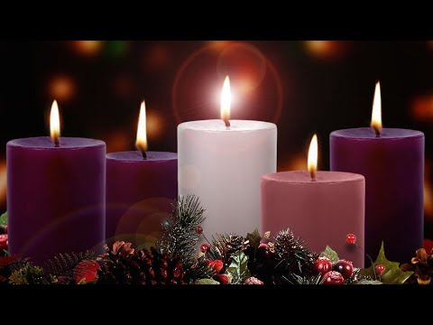

Setup - Before the prayer set up a sacred space. Clear your dinner table or other table. Include a candle, bell, symbols and coloured cloth. Invite others well ahead of time before you pray.

We put ourselves in the presence of our God by focusing on our breathing. Breath in and out. Breath in and out.

As we ring our bell and light our Candle
We invite God’s presence to be with Us.

Sign of the Cross.
In the name of the Father, and of the Son, and of the Holy Spirit.
Amen.

Final Song – O come, O come, Emmanuel
https://www.youtube.com/watch?v=7xtpJ4Q_Q-4

1. O come, O come, Emmanuel,
And ransom captive Israel,
That mourns in lonely exile here
Until the Son of God appear.

Refrain - Rejoice! Rejoice!
Emmanuel shall come to thee, O Israel.

2. O come, Thou Wisdom from on high,
Who orderest all things mightily;
To us the path of knowledge show,
And teach us in her ways to go.

3. O come, O come, thou Lord of might,
Who to thy tribes, on Sinai’s height,
In ancient times didst give the law
In cloud and majesty and awe.

4. O come, Thou Rod of Jesse, free
Thine own from Satan’s tyranny;
From depths of hell Thy people save,
And give them victory over the grave.

Gospel – Luke 1:39-45
Mary set out
and travelled to the hill country in haste
to a town of Judah,
where she entered the house of Zechariah
and greeted Elizabeth.
When Elizabeth heard Mary’s greeting,
the infant leaped in her womb,
and Elizabeth, filled with the Holy Spirit,
cried out in a loud voice and said,
“Blessed are you among women,
and blessed is the fruit of your womb.
And how does this happen to me,
that the mother of my Lord should come to me?
For at the moment the sound of your greeting reached my ears,
the infant in my womb leaped for joy.
Blessed are you who believed
that what was spoken to you by the Lord
would be fulfilled.”

The Gospel of the Lord.

All – Praise to you Lord Jesus Christ.

Reflection
This is the story of the visitation. Of two women coming together with great joy. Knowing in their beings the great wonder which each reflected. But despite these joys the great difficulties each had to live through. Elizabeth as an old woman with the shame of not having a child. Mary as a teenager having a child outside of marriage. There is a level of social stigma. Yet. God makes the impossible possible. It is through this messiness that God appears, and joy emerges.

Silence
Take a minute in silence to reflect on today’s Gospel.

Discuss
- What difficulties and messiness have you had to live through this year?
- Often joy emerges when we have lived through great difficulty. Have you experienced this this year? If so, where?
- Where does the Christ child need to born today? In the poor? In the environment? in the family? Explain.

Reflection Video
CeeLo Green - Mary did you know?
https://www.youtube.com/watch?v=1Z-ZfAlrgJs

Prayers of the Faithful
We bring the following prayers to God.
1. As we journey towards Christmas,
Give us patience. Patience to wait for Christ to be born in us today.
Lord hear us.

2. May we follow Mary’s, Joseph’s, and Elizabeth’s, example of hope. Form us God to be a people of hope. Lord hear us.

3. We pray for the doctors and nurses across the world who risk their lives to care for others.
We thank God for them. Lord hear us.

4. We pray for the forgotten over Christmas. The homeless, the refugees, women facing domestic violence, those dealing with mental illness and the unloved. May we be a sign of hope for these people. Lord hear us.

Any other prayers?

Final Prayer
Come to us owe Holy Spirit.
May Christ be born in us today.
Bless us with gift of your Son.
God of yesterday, today and tomorrow
May your eternal Word
Transform our doubts and struggle
May the joy of your Son
Be with us this Christmas.
Amen

Final Song –Emmanuel
https://www.youtube.com/watch?v=HnAKAB4OYik

Come, come, Emmanuel!
Son of God, appear.
Heaven and earth, rejoice!
Salvation is drawing near.
Salvation is drawing near.

O come, O come, Emmanuel,
And ransom captive Israel,
That mourns in lonely exile here
Until the Son of God appear.

O come, O Wisdom from on high,
Who ordered all things mightily;
To us the path of knowledge show,
And teach us in her ways to go.

O come, O Rod of Jesse’s stem;
From ev’ry foe deliver them
That trust your mighty pow’r to save,
And give them vict’ry o’er the grave.

O come, Desire of nations, bind
In one the hearts of humankind;
Make all our sad divisions cease,
And be for us the King of Peace.

After final refrain
Rejoice! Emmanuel
shall come to thee, O Israel. (twice)

Sign of the Cross.
In the name of the Father, and of the Son, and of the Holy Spirit.
Amen.

