Australia Day Prayer
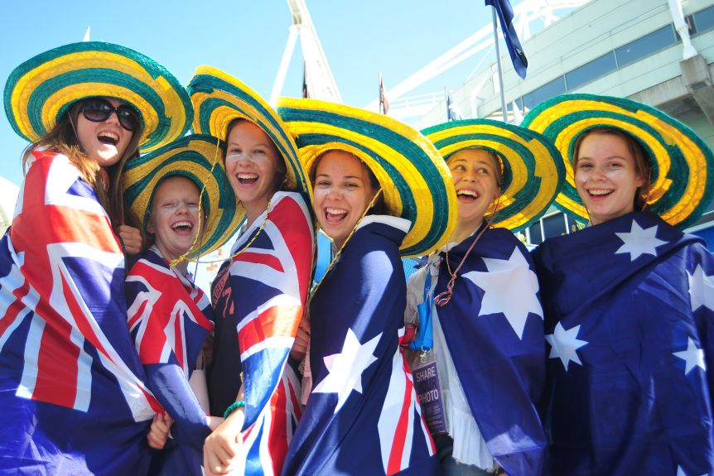
Sign of the Cross

Opening Prayer - St Patrick
I arise today
Through a mighty strength, the invocation of the Trinity,
Through belief in the Threeness,
Through confession of the Oneness
of the Creator of creation.

Christ with me,
Christ before me,
Christ behind me,
Christ in me,
Christ beneath me,
Christ above me,
Christ on my right,
Christ on my left,
Christ when I lie down,
Christ when I sit down,
Christ when I arise,
Christ in the heart of every man who thinks of me,
Christ in the mouth of everyone who speaks of me,
Christ in every eye that sees me,
Christ in every ear that hears me.
Amen

Gospel – Mark 3:31-35
The mother of Jesus and his brothers arrived at the house.
Standing outside, they sent word to Jesus and called him.
A crowd seated around him told him,
“Your mother and your brothers and your sisters
are outside asking for you.”
But he said to them in reply,
“Who are my mother and my brothers?”
And looking around at those seated in the circle he said,
“Here are my mother and my brothers.
For whoever does the will of God
is my brother and sister and mother.”

Discuss
What is the meaning of today’s Gospel?

Common Prayer

- We pray for our neighbours. May they open their hearts to speak to each other and form community. May they learn to care for each other. Lord Hear us.
- We pray for the Aboriginal People. May all Australians open their hearts so that we all may become one people. May the date of January 26 be changed in recognition to Aboriginal dispossession. Lord hear us.
- We pray for refugees. Those who have travelled across the sea in fear. May Australians opening their hearts to helping those in need. Lord hear us.
- We pray for all Australians. We thank you for the goodness that Australians have brought to our world. May we celebrate this goodness, but also care for each other in mateship. Lord hear us.
Any other prayers?

Prayer – Australian Litany
Sing praise to God sing praise.
We pray with God for Australia.

1. For the first people of our Country
Response Sing praise to God.

2. For refugees and those fleeing violence.
Response We pray Australians might
help

3. For our neighbours
Response We pray that we might
build community.

4. For where there is division and hurt
Response Open our hearts to forgiveness

5. For riches of our country
Response We pray that we learn to
share.

6. For our grandmothers and grand fathers
Response We thank you God.

7. For our Pacific and Asian neighbours.
Response May Australians care for you
as brothers and sisters.

Closing Prayer
God our Father and Mother we thank you for Australia. For its beauty in its land, its people and its environment. Call us to renew us as one people. May Australia be an instrument of goodness to shape the world and its future.
Amen.

Sign of the Cross

