Daily Family Prayer
April 1

As we light our candle and ring our bell
We pray that God is with us.

In the name of the Father, and of the Son, and of the Holy Spirit. Amen.
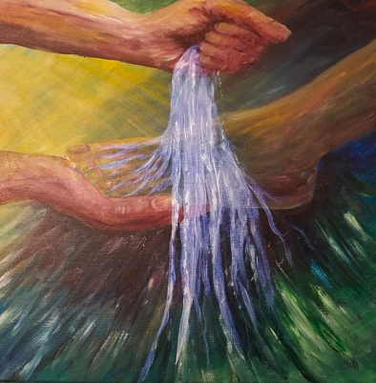

Gospel Matthew 26:14-25

Before the feast of Passover, Jesus knew that his hour had come
to pass from this world to the Father.
He loved his own in the world and he loved them to the end.
The devil had already induced Judas, son of Simon the Iscariot, to hand him over.
So, during supper,
fully aware that the Father had put everything into his power
and that he had come from God and was returning to God,
he rose from supper and took off his outer garments.
He took a towel and tied it around his waist.
Then he poured water into a basin
and began to wash the disciples’ feet
and dry them with the towel around his waist.
He came to Simon Peter, who said to him,
“Master, are you going to wash my feet?”
Jesus answered and said to him,
“What I am doing, you do not understand now,
but you will understand later.”
Peter said to him, “You will never wash my feet.”
Jesus answered him,
“Unless I wash you, you will have no inheritance with me.”
Simon Peter said to him,
“Master, then not only my feet, but my hands and head as well.”
Jesus said to him,
“Whoever has bathed has no need except to have his feet washed,
for he is clean all over;
so you are clean, but not all.”
For he knew who would betray him;
for this reason, he said, “Not all of you are clean.”

So when he had washed their feet
and put his garments back on and reclined at table again,
he said to them, “Do you realize what I have done for you?
You call me ‘teacher’ and ‘master,’ and rightly so, for indeed I am.
If I, therefore, the master and teacher, have washed your feet,
you ought to wash one another’s feet.
I have given you a model to follow,
so that as I have done for you, you should also do.”
The Gospel of the Lord

ALL – Praise to you Lord Jesus Christ.

Pope Francis - Washing the feet
https://www.youtube.com/watch?v=0Fr4269x-cY

Silence
In silence reflect on the following questions.

Discussion Questions
- Why does Jesus’ wash the disciple’s feet just before he is taken away? What image or model does he want us to remember of him?
- How does “washing of the feet” speak to us about authentic Christian leadership?
- How are we called to serve one another?

Common prayer
- We pray that we to might be open to receive Christ as the one who washes our feet and washes the parts of us which are deeply in need. Lord hear us.
- We pray for the desire to serve one another. May we step out of business as usual and care for the poor and the forgotten. Lord hear us.
- We pray that this time of Christs death and resurrection that we too might follow as a follow too. Lord hear us.
- We pray for Myanmar and Burma. That peace may enter the hearts of their leaders. Lord hear us.
- We pray for those who suffer human rights abuse. In places like Xinjiang Western China and the refugee camps in Australia. We pray that human hearts might be open with compassion to help them. Lord hear us.
- Any other prayers?

Song – Remembrance – Matt Maher
https://www.youtube.com/watch?v=ItcURbkjXOA&t=4s

Lord we bring these prayers both said and unsaid through the

Prayer
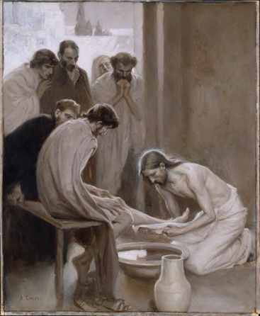
Dear Lord
Wash me owe Lord
With your tender touch.
Wash me owe Lord
With your Holy Presence.
Wash me owe Lord
with your healing hands.
Wash me owe Lord
And renew my mind.
Wash me owe Lord
Of my sorrows and regrets
Wash me owe Lord
Cleanse me from my sin.
Wash me owe Lord
So that I might serve.
Wash me owe Lord
So that I might know your ways.
Wash me owe Lord
From death to new life.
Loving waters of the Great Divine
Pour out your presence
Holy Father,
Loving Brother
Inspiring Spirit.
Upon us now.
Pause for 20 seconds….

Amen

As blow the candle out and ring our bell
We pray that God is with us this day.

In the name of the Father, and of the Son, and of the Holy Spirit.
Amen

