Daily Family Prayer
April 9

As we light our candle and ring our bell
We pray that God is with us.

In the name of the Father, and of the Son, and of the Holy Spirit. Amen.

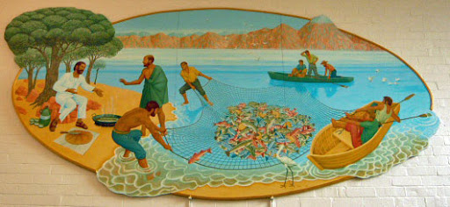

Gospel John 21:1-14

Jesus revealed himself again to his disciples at the Sea of Tiberias.
He revealed himself in this way.
Together were Simon Peter, Thomas called Didymus,
Nathanael from Cana in Galilee,
Zebedee’s sons, and two others of his disciples.
Simon Peter said to them, “I am going fishing.”
They said to him, “We also will come with you.”
So they went out and got into the boat,
but that night they caught nothing.
When it was already dawn, Jesus was standing on the shore;
but the disciples did not realize that it was Jesus.
Jesus said to them, “Children, have you caught anything to eat?”
They answered him, “No.”
So he said to them, “Cast the net over the right side of the boat
and you will find something.”
So they cast it, and were not able to pull it in
because of the number of fish.
So the disciple whom Jesus loved said to Peter, “It is the Lord.”
When Simon Peter heard that it was the Lord,
he tucked in his garment, for he was lightly clad,
and jumped into the sea.
The other disciples came in the boat,
for they were not far from shore, only about a hundred yards,
dragging the net with the fish.
When they climbed out on shore,
they saw a charcoal fire with fish on it and bread.
Jesus said to them, “Bring some of the fish you just caught.”
So Simon Peter went over and dragged the net ashore
full of one hundred fifty-three large fish.
Even though there were so many, the net was not torn.
Jesus said to them, “Come, have breakfast.”
And none of the disciples dared to ask him, “Who are you?”
because they realized it was the Lord.
Jesus came over and took the bread and gave it to them,
and in like manner the fish.
This was now the third time Jesus was revealed to his disciples
after being raised from the dead.

ALL – Praise to you Lord Jesus Christ.

Jesus appears at the Sea of Tiberias
https://www.youtube.com/watch?v=nA14i1Bshdo

Silence
In silence reflect on the following questions.

Discussion Questions
- Why don’t the disciples recognise Jesus?
- Why don’t the disciples ask Jesus “who are you”?
- What does “taking the bread, breaking it and giving this to them” mean?
- How does Jesus appear to us in the ordinariness of our lives?

Common prayer
- We pray that we too might have the faith to search for and recognise Jesus in our lives. Lord hear us.
- We pray for those in our own family and friends who have lost faith in God. May they build a desire to search for God. Lord hear us.
- We pray for the people in Timor and Indonesia who have been caught up in the floods. May the world send them help. Lord hear us.
- We pray for Myanmar and Burma. That peace may enter the hearts of their leaders. Lord hear us.
- Any other prayers?

Song – Awake my soul – Chris Tomlin
https://www.youtube.com/watch?v=fWpvknKuYrg

Lord we bring these prayers both said and unsaid through the

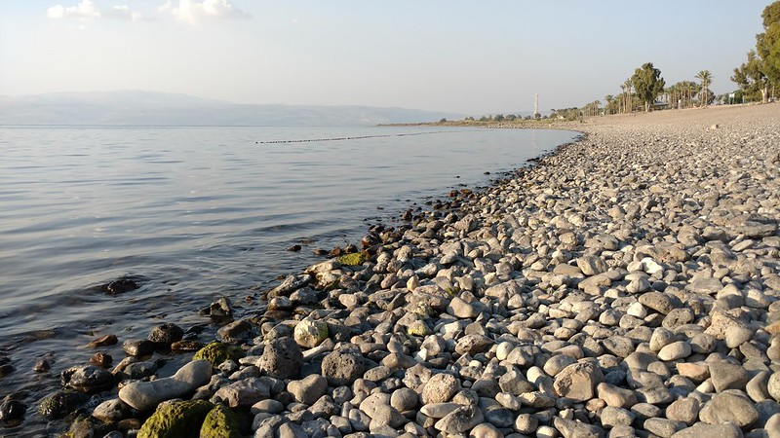

Prayer
Dear Lord,
May we set sail across the oceans to find God hidden in our own lives.
Despite the storms of yesterday, today and tomorrow,
may we learn to trust stay afloat.
Awaken in us signs of hope.
May we look to the stars and search for deeper truths.
As we come to shore.
Share with us the breaking of the bread
And may we eat this bread and drink this cup
So that we to might break the bread for others.
Who witness Jesus’ resurrection
as we sail the oceans
in our thoughts, deeds and actions.

Amen

As blow the candle out and ring our bell
We pray that God is with us this day.

In the name of the Father, and of the Son, and of the Holy Spirit.
Amen

