Daily Family Prayer
March 23

As we light our candle and ring our bell
We pray that God is with us.

In the name of the Father, and of the Son, and of the Holy Spirit.
Amen. 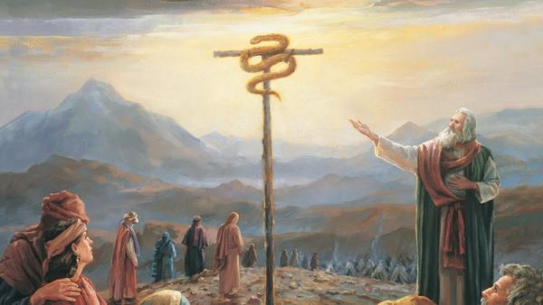

Gospel John 8:21-30

Jesus said to the Pharisees:
“I am going away and you will look for me,
but you will die in your sin.
Where I am going you cannot come.”
So the Jews said,
“He is not going to kill himself, is he,
because he said, ‘Where I am going you cannot come’?”
He said to them, “You belong to what is below,
I belong to what is above.
You belong to this world,
but I do not belong to this world.
That is why I told you that you will die in your sins.
For if you do not believe that I AM,
you will die in your sins.”
So they said to him, “Who are you?”
Jesus said to them, “What I told you from the beginning.
I have much to say about you in condemnation.
But the one who sent me is true,
and what I heard from him I tell the world.”
They did not realize that he was speaking to them of the Father.
So Jesus said to them,
“When you lift up the Son of Man,
then you will realize that I AM,
and that I do nothing on my own,
but I say only what the Father taught me.
The one who sent me is with me.
He has not left me alone,
because I always do what is pleasing to him.”
Because he spoke this way, many came to believe in him.
The Gospel of the Lord.

ALL – Praise to you Lord Jesus Christ.

Silence
In silence reflect on the following questions.

Discussion Questions
- Who were the Pharisees?
- What is sin?
- Jesus said “you will die in our sin” several times. What does he mean?
- What does it mean 2000 years ago in first century Palestine – “When you lift up the Son of Man”? What does it mean for us today?
- The Gospel ends with “many came to believe in him”. What are 3 ways you can strengthen your own faith?

Common prayer
- We pray for our family members or friends who are sick at this time. Think of someone you can pray for. Pause for 10 seconds…. Lord hear us.
- We pray for those caught in the devasting floods in Australia. Lord hear us.
- We pray for the world. That we might awaken to be carers of creation.
- Any other prayers?

Song – In Christ Alone
https://www.youtube.com/watch?v=16KYvfIc2bE
In Christ alone my hope is found,
He is my light, my strength, my song
This Cornerstone, this solid Ground
Firm through the fiercest drought and storm.
What heights of love, what depths of peace
When fears are stilled, when strivings cease
My Comforter, my All in All
Here in the love of Christ I stand.

In Christ alone! - who took on flesh,
Fullness of God in helpless babe.
This gift of love and righteousness,
Scorned by the ones He came to save
Till on that cross as Jesus died,
The wrath of God was satisfied
For every sin on Him was laid
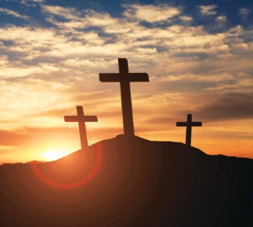
Here in the death of Christ I live.

There in the ground His body lay,
Light of the world by darkness slain:
Then bursting forth in glorious day
Up from the grave He rose again
And as He stands in victory
Sin's curse has lost its grip on me,
For I am His and He is mine
Bought with the precious blood of Christ……

Prayer - Our Father

Prayer – Hail Mary

Prayer – Glory Be

As blow the candle out and ring our bell
We pray that God is with us this day.

In the name of the Father, and of the Son, and of the Holy Spirit.
Amen

