Daily Family Prayer
March 24

As we light our candle and ring our bell
We pray that God is with us.

In the name of the Father, and of the Son, and of the Holy Spirit. Amen.

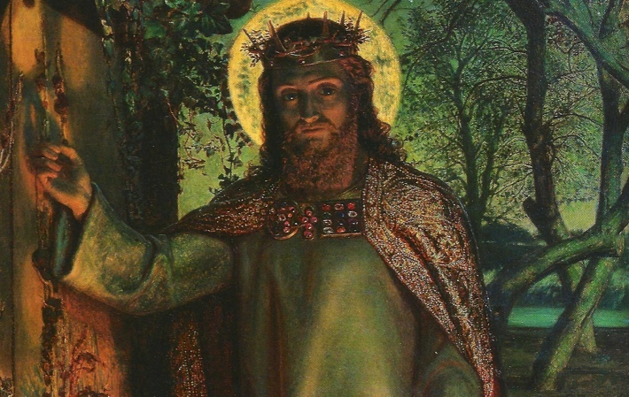

Gospel John 8:31-42

Jesus said to those Jews who believed in him,
“If you remain in my word, you will truly be my disciples,
and you will know the truth, and the truth will set you free.”
They answered him, “We are descendants of Abraham
and have never been enslaved to anyone.
How can you say, ‘You will become free’?”
Jesus answered them, “Amen, amen, I say to you,
everyone who commits sin is a slave of sin.
A slave does not remain in a household forever,
but a son always remains.
So if the Son frees you, then you will truly be free.
I know that you are descendants of Abraham.
But you are trying to kill me,
because my word has no room among you.
I tell you what I have seen in the Father’s presence;
then do what you have heard from the Father.”

They answered and said to him, “Our father is Abraham.”
Jesus said to them, “If you were Abraham’s children,
you would be doing the works of Abraham.
But now you are trying to kill me,
a man who has told you the truth that I heard from God;
Abraham did not do this.
You are doing the works of your father!”
So they said to him, “We were not born of a sexual sin.
We have one Father, God.”
Jesus said to them, “If God were your Father, you would love me,
for I came from God and am here;
I did not come on my own, but he sent me.”
The Gospel of the Lord.

ALL – Praise to you Lord Jesus Christ.

Silence
In silence reflect on the following questions.

Discussion Questions
- “if you remain in my Word”… What does that mean?
- What do you know about Abraham?
- Why did the Jews want Abraham as their father?
- Explain the following….“anyone who commits sin is a slave of sin”.
- How might our beliefs and behaviours change “If God were our father”?

Common prayer
- We pray that we might turn to God as our own father. Lord hear us.
- We pray for Myanmar and Burma. That peace may enter the hearts of their leaders. Lord hear us.
- We pray for those caught in the devasting floods in Australia. Lord hear us.
- We pray for Marists around the world. Fill them with the courage to live of Gospel. Lord hear us.
- Any other prayers?

Song – Thy Word
https://www.youtube.com/watch?v=a6LC8cu03Ig

Thy Word is a lamp unto my feet and a light unto my path
Thy Word is a lamp unto my feet and a light unto my path

1. When I feel afraid
Think I've lost my way

Still you're there right beside me
And nothing will I fear
As long as you are near
Please be near me to the end

2. I will not forget
Your love for me and yet
My heart forever is wandering
Jesus be my guide
And hold me to your side
I will love you to the end
Nothing will I fear as long as you are near
Please be near me to the end

Prayer - Our Father

Prayer – Hail Mary

Prayer – Glory Be

As blow the candle out and ring our bell
We pray that God is with us this day.

In the name of the Father, and of the Son, and of the Holy Spirit.
Amen

