Daily Family Prayer
March 25

As we light our candle and ring our bell
We pray that God is with us.

In the name of the Father, and of the Son, and of the Holy Spirit. Amen.

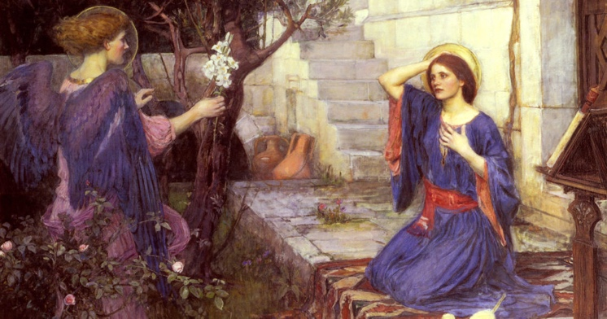

Gospel Luke 1:26-38

The angel Gabriel was sent from God
to a town of Galilee called Nazareth,
to a virgin betrothed to a man named Joseph,
of the house of David,
and the virgin’s name was Mary.
And coming to her, he said,
“Hail, full of grace! The Lord is with you.”
But she was greatly troubled at what was said
and pondered what sort of greeting this might be.
Then the angel said to her,
“Do not be afraid, Mary,
for you have found favor with God.
Behold, you will conceive in your womb and bear a son,
and you shall name him Jesus.
He will be great and will be called Son of the Most High,
and the Lord God will give him the throne of David his father,
and he will rule over the house of Jacob forever,
and of his Kingdom there will be no end.”
But Mary said to the angel,
“How can this be,
since I have no relations with a man?”
And the angel said to her in reply,
“The Holy Spirit will come upon you,
and the power of the Most High will overshadow you.
Therefore the child to be born
will be called holy, the Son of God.
And behold, Elizabeth, your relative,
has also conceived a son in her old age,
and this is the sixth month for her who was called barren;
for nothing will be impossible for God.”
Mary said, “Behold, I am the handmaid of the Lord.
May it be done to me according to your word.”
Then the angel departed from her.
The Gospel of the Lord.

ALL – Praise to you Lord Jesus Christ.

Silence
In silence reflect on the following questions.

Discussion Questions
- What has the angel asked of Mary?
- What did Mary know at 13 years of age when she said “yes”?
- The angel said “do not be afraid”. When have you been afraid?
- When in your life have you been asked to do something hard? How did you trust?

Common prayer
- We pray that we to might say yes to God. Give us courage to live more deeply in your ways. Lord hear us.
- We pray for women across the world suffering persecution and abuse. May God comfort them. Lord hear us.
- We pray for Myanmar and Burma. That peace may enter the hearts of their leaders. Lord hear us.
- We pray for those caught in the devasting floods in Australia. Lord hear us.
- Any other prayers?

Song – Mary did you know
https://www.youtube.com/watch?v=1Z-ZfAlrgJs

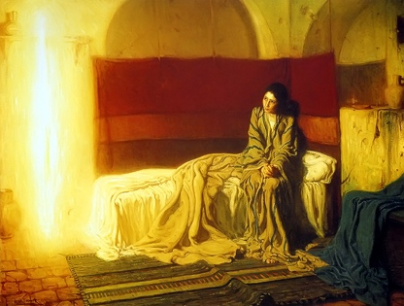
Awaken Prayer
Ancient eternal One,
Awaken in us a deeper desire to bring hope.
As we learn, may we look beyond what we see.
To a deeper reality.
To find you living in the poor, the outcast and in the earth.
Turn our hearts and minds to follow your son Jesus.
To journey beyond the comfort zones of our lives.
As we awaken like Mary’s “yes” to the angel Gabrielle.
Let us be the instruments of goodness.
To be brothers and sisters to each other.
So as to transform the places that seem dark.
Lead us to care for a world and future not our own.
May our community bring the light that sings
the glory of God’s creation.

Amen.

Prayer – Our Father
Prayer – Hail Mary
Prayer – Glory Be

As blow the candle out and ring our bell
We pray that God is with us this day.

In the name of the Father, and of the Son, and of the Holy Spirit.
Amen

