Daily Family Prayer
March 26

As we light our candle and ring our bell
We pray that God is with us.

In the name of the Father, and of the Son, and of the Holy Spirit. Amen.

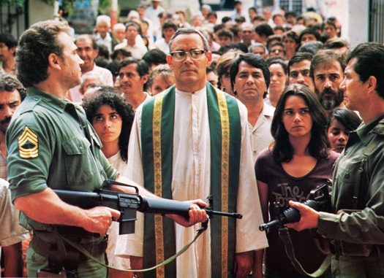

Gospel John 10:31-32

The Jews picked up rocks to stone Jesus.
Jesus answered them, “I have shown you many good works from my Father.
For which of these are you trying to stone me?”
The Jews answered him,
“We are not stoning you for a good work but for blasphemy.
You, a man, are making yourself God.”
Jesus answered them,
“Is it not written in your law, ‘I said, ‘You are gods”‘?
If it calls them gods to whom the word of God came,
and Scripture cannot be set aside,
can you say that the one
whom the Father has consecrated and sent into the world
blasphemes because I said, ‘I am the Son of God’?
If I do not perform my Father’s works, do not believe me;
but if I perform them, even if you do not believe me,
believe the works, so that you may realize and understand
that the Father is in me and I am in the Father.”
Then they tried again to arrest him;
but he escaped from their power.

He went back across the Jordan
to the place where John first baptized, and there he remained.
Many came to him and said,
“John performed no sign,
but everything John said about this man was true.”
And many there began to believe in him.
The Gospel of the Lord.

ALL – Praise to you Lord Jesus Christ.

Video – Modern Prophet – Oscar Romero
https://www.youtube.com/watch?v=8G27jc6l_Zk

Silence
In silence reflect on the following questions.

Discussion Questions
- How is Oscar Romero a prophet?
- Why do people stone prophets?
- Do you know any prophets who have had a hard time? Who?
- “You are gods”…and “I am the son of God”. What does Jesus mean? Why is hard for the Jews to believe?
- Why is it so hard to believe Jesus…both in Jesus’ time 2000 years ago in Palestine and for today?

Common prayer
- We pray for prophets both young and old. Give them the courage to stand for what they believe. Lord hear us.
- We pray for those who struggle with their faith to believe in God. God fill them with a taste for God. Lord hear us.
- We pray for Myanmar and Burma. That peace may enter the hearts of their leaders. Lord hear us.
- We pray for those caught in the devasting floods in Australia. Lord hear us.
- Any other prayers?

Song – If Anyone Cared – Nickelback
https://www.youtube.com/watch?v=-IUSZyjiYuY

Oscar Romero Prayer
It helps, now and then, to step back and take a long view.
The kingdom is not only beyond our efforts,
it is even beyond our vision.

We accomplish in our lifetime
only a tiny fraction
of the magnificent enterprise
that is God's work.
Nothing we do is complete,
which is another way of saying
that the Kingdom always lies beyond us.

No statement says all that could be said.
No prayer fully expresses our faith.
No confession brings perfection.
No pastoral visit brings wholeness.
No programme
accomplishes the Church's mission.
No set of goals and objectives
includes everything.

That is what we are about.
We plant a seed that will one day grow.
We water seeds already planted,
knowing that they hold future promise.
We lay foundations
that will need further development.
We provide yeast that produces effects
far beyond our capabilities.

We cannot do everything,
and there is a sense of liberation
in realising that.
This enables us to do something,
and to do it very well.

It may be incomplete,
but it is a beginning,
a step along the way,
an opportunity for the Lord's grace
to enter and do the rest.

We may never see the end results,
but that is the difference
between the master builder and the worker.
We are workers, not master builders,
ministers, not messiahs.
We are prophets of a future not our own.

As blow the candle out and ring our bell
We pray that God is with us this day.

In the name of the Father, and of the Son, and of the Holy Spirit.
Amen

