Daily Family Prayer
March 27

As we light our candle and ring our bell
We pray that God is with us.

In the name of the Father, and of the Son, and of the Holy Spirit. Amen.

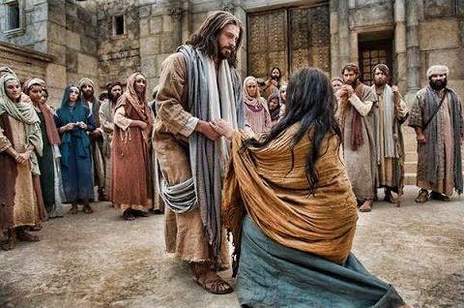

Gospel John 11:45-56

Many of the Jews who had come to Mary
and seen what Jesus had done began to believe in him.
But some of them went to the Pharisees
and told them what Jesus had done.
So the chief priests and the Pharisees
convened the Sanhedrin and said,
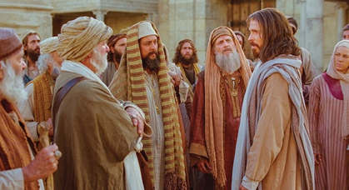
“What are we going to do?
This man is performing many signs.
If we leave him alone, all will believe in him,
and the Romans will come
and take away both our land and our nation.”
But one of them, Caiaphas,
who was high priest that year, said to them,
“You know nothing,
nor do you consider that it is better for you
that one man should die instead of the people,
so that the whole nation may not perish.”
He did not say this on his own,
but since he was high priest for that year,
he prophesied that Jesus was going to die for the nation,
and not only for the nation,
but also to gather into one the dispersed children of God.
So from that day on they planned to kill him.

So Jesus no longer walked about in public among the Jews,
but he left for the region near the desert,
to a town called Ephraim,
and there he remained with his disciples.

Now the Passover of the Jews was near,
and many went up from the country to Jerusalem
before Passover to purify themselves.
They looked for Jesus and said to one another
as they were in the temple area, “What do you think?
That he will not come to the feast?”

ALL – Praise to you Lord Jesus Christ.

Silence
In silence reflect on the following questions.

Discussion Questions
- Why would people want to follow Jesus?
- What is jealousy?
- Why do the pharisees want to kill Jesus? Isn’t this breaking one of the ten commandments?
- What did Caiaphas prophesy and say about Jesus?
- Why could people not move around publicly?
- Name 2 or 3 people who courageously stand up for what they believe in? Are they attacked?
- Are you called to stand up for what you believe?

Common prayer
- We pray for the courage to stand up for what is right. Especially in times that seem hardest. Lord hear us.
- We pray that we too might be followers of Jesus. People who pick up our crosses and walk. Lord hear us.
- We pray for Myanmar and Burma. That peace may enter the hearts of their leaders. Lord hear us.
- We pray for those who suffer human rights abuse. In places like Xinjiang Western China and the refugee camps in Australia. We pray that human hearts might be open with compassion to help them. Lord hear us.
- Any other prayers?

Song – Where is the love – Black Eyed Pea
https://www.youtube.com/watch?v=WpYeekQkAdc

Lord we bring these prayers both said and unsaid through the

Prayer of Saint Francis
Lord, make me an instrument of your peace:
where there is hatred, let me sow love;
where there is injury, pardon;
where there is doubt, faith;
where there is despair, hope;
where there is darkness, light;
where there is sadness, joy.

O divine Master, grant that I may not so much seek
to be consoled as to console,
to be understood as to understand,
to be loved as to love.
For it is in giving that we receive,
it is in pardoning that we are pardoned,
and it is in dying that we are born to eternal life.
Amen.

As blow the candle out and ring our bell
We pray that God is with us this day.

In the name of the Father, and of the Son, and of the Holy Spirit.
Amen

