Daily Family Prayer
March 31

As we light our candle and ring our bell
We pray that God is with us.

In the name of the Father, and of the Son, and of the Holy Spirit. Amen.

Gospel Matthew 26:14-25

One of the Twelve, who was called Judas Iscariot,
went to the chief priests and said,
“What are you willing to give me
if I hand him over to you?”
They paid him thirty pieces of silver,
and from that time on he looked for an opportunity to hand him over.

On the first day of the Feast of Unleavened Bread,
the disciples approached Jesus and said,
“Where do you want us to prepare
for you to eat the Passover?”
He said,
“Go into the city to a certain man and tell him,
‘The teacher says, My appointed time draws near;
in your house I shall celebrate the Passover with my disciples.”‘
The disciples then did as Jesus had ordered,
and prepared the Passover.

When it was evening,
he reclined at table with the Twelve.
And while they were eating, he said,
“Amen, I say to you, one of you will betray me.”
Deeply distressed at this,
they began to say to him one after another,
“Surely it is not I, Lord?”
He said in reply,
“He who has dipped his hand into the dish with me
is the one who will betray me.
The Son of Man indeed goes, as it is written of him,
but woe to that man by whom the Son of Man is betrayed.
It would be better for that man if he had never been born.”
Then Judas, his betrayer, said in reply,
“Surely it is not I, Rabbi?”
He answered, “You have said so.”

ALL – Praise to you Lord Jesus Christ.

Silence
In silence reflect on the following questions.

Discussion Questions
- In the film Mary Magdalene Judas is portrayed as a man who has lost his child and wife to the Romans. He eagerly awaits for Jesus to rise up and bring about the kingdom of God to restore the lives of Judas’ lost ones. Do you think Judas feels betrayed by Judas?
- Why does Judas betray Jesus?
- When have you felt betrayed?
- Instead of speaking and plotting behind people’s back what can we do?

Common prayer
- We pray for the times we have felt betrayed and when have betrayed us. Lord give us the courage to speak the truth. Lord hear us.
- We pray for greater faith and greater trust in each other. May we not jump to conclusion but witness to each other a deeper call to live the Gospel. Lord hear us.
- We pray for Myanmar and Burma. That peace may enter the hearts of their leaders. Lord hear us.
- We pray for those who suffer human rights abuse. In places like Xinjiang Western China and the refugee camps in Australia. We pray that human hearts might be open with compassion to help them. Lord hear us.
- Any other prayers?

Song – Jesus’ betrayal by Judas
https://www.youtube.com/watch?v=k88Y8VGs7dY

Lord we bring these prayers both said and unsaid through the
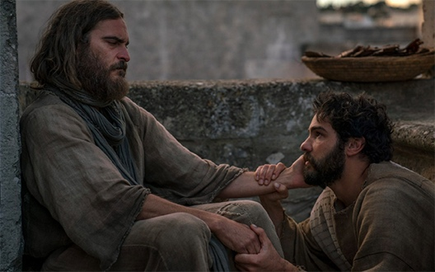

Prayer of winter of betrayal
Dear Lord
We plant the seeds hoping that tomorrow they might spring new life.
When winter comes the leaves fall and the life withers away in us.
We forget the story of the spring morning
When new baby bird’s chirp
And dew on the grass renews the earth.
Instead, our minds are filled with bitterness
Of cold moments which clouds our day.
We are sorry for these moments Lord in our life.
We have become Judas.
When darkness grips up
And we wish to run away in our fear.
Hold us fast in these moments.
Hold us fast in our pains.
May we seek you more and more
In moments of our own winter.
In moments we cannot control.
Lord change us
So that we too might realise
The spring that emerges from winter.
Jesus Christ who lives in us.
Amen

As blow the candle out and ring our bell
We pray that God is with us this day.

In the name of the Father, and of the Son, and of the Holy Spirit.
Amen

