Family Prayer

Sunday March 14

Setup - Before the prayer set up a sacred space. Clear your dinner table or other table. Include a candle, bell, symbols and coloured cloth. Invite others well ahead of time before you pray.

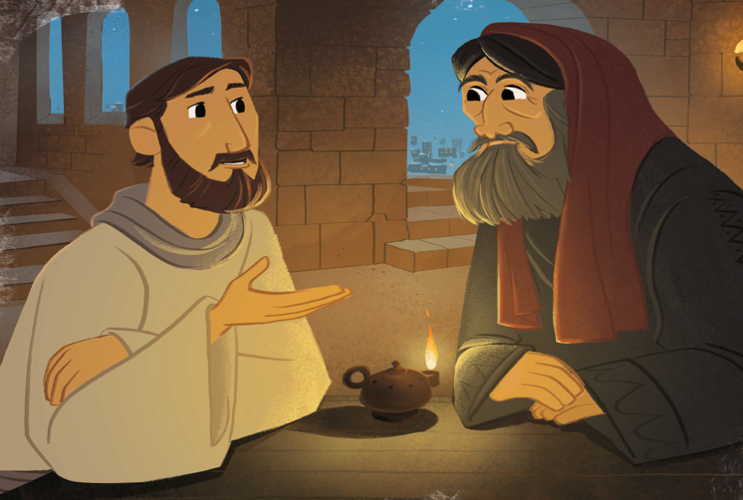

We put ourselves in the presence of our God by focusing on our breathing. Breath in and out. Breath in and out.

As we ring our bell and light our Candle
We invite God’s presence to be with Us.

Sign of the Cross.
In the name of the Father, and of the Son, and of the Holy Spirit.
Amen.

Opening Song – Run to the Father
Matt Maher
https://www.youtube.com/watch?v=SQPfFNRw4Rs

Gospel – John 3:14-21

Jesus said to Nicodemus:
“Just as Moses lifted up the serpent in the desert,
so must the Son of Man be lifted up,
so that everyone who believes in him may have eternal life.”

For God so loved the world that he gave his only Son,
so that everyone who believes in him might not perish
but might have eternal life.
For God did not send his Son into the world to condemn the world,
but that the world might be saved through him.
Whoever believes in him will not be condemned,
but whoever does not believe has already been condemned,
because he has not believed in the name of the only Son of God.
And this is the verdict,
that the light came into the world,
but people preferred darkness to light,
because their works were evil.
For everyone who does wicked things hates the light
and does not come toward the light,
so that his works might not be exposed.
But whoever lives the truth comes to the light,
so that his works may be clearly seen as done in God.

The Gospel of the Lord.

All – Praise to you Lord Jesus Christ.

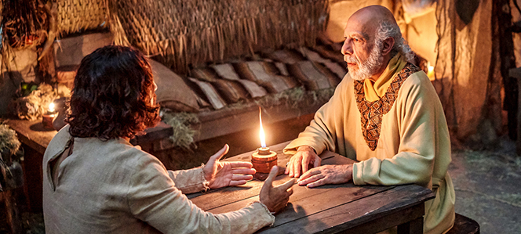

Video – Jesus and Nicodemus
Listen from 48 seconds to 4 minutes and 50 seconds
https://youtu.be/_p2XIUK9VgA?t=48

Silence
Take a minute in silence to reflect on today’s Gospel.

Song – Lord I Need you
Matt Maher
https://www.youtube.com/watch?v=gS9e0nxHP-w

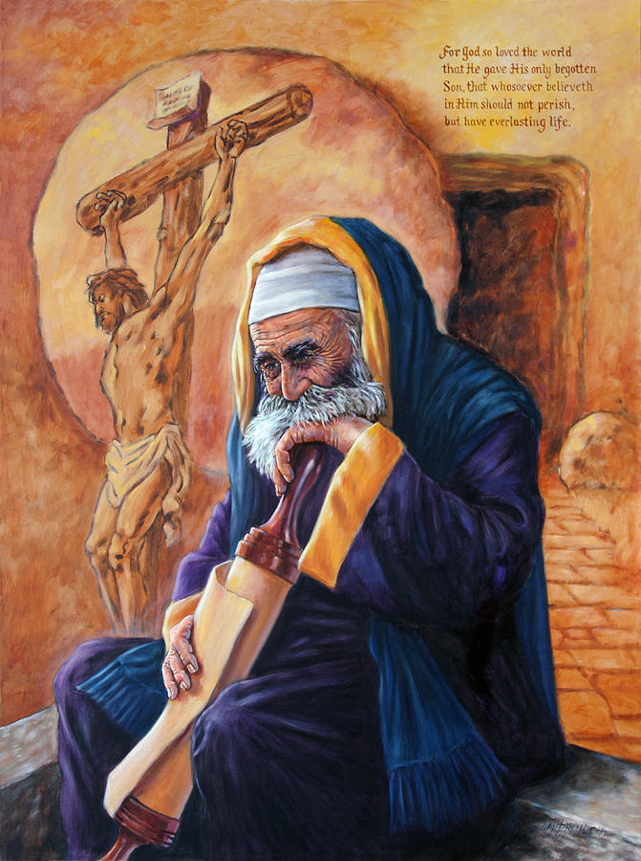

Discuss
- Why is Nicodemus so excited?
- What does Nicodemus believe? Why?
- What is Jesus come to show us? Explain.
- How can a person enter the Kingdom of God?
- Why does Jesus ask Nicodemus about the wind? How is like the Spirit?
- Why is so hard to receive and understanding?

Prayers of the Faithful
We bring the following prayers to God.
- During Lent we pray that we will draw closer to God through our prayers, through our fasting from the things we like, and through good works especially when it most difficult. Lord Hear Us.
Response – Lord hear our prayer.
- We pray for the school’s girls who were stolen from their school in Nigeria. Please return them home Lord safely. Lord Hear Us.
Response – Lord hear our prayer.
- We pray for women and girls across the world. Especially those suffering persecution and abuse. We pray that we might become instruments of hope for these women and girls. Lord Hear us.
Response – Lord hear our prayer.
- We pray for the earth. Cause us Lord to take seriously climate change and the many animals and plants facing extinction. Call us to change our hearts our Lord. Lord Hear us.
Response – Lord hear our prayer.
- Are there any other prayers?
Response – Lord hear our prayer.

Leader - We bring these prayers both send and unsaid to you as we pray the awaken prayer.

Awaken Prayer
Ancient eternal One,
Awaken in us a deeper desire to bring hope.
As we learn, may we look beyond what we see.
To a deeper reality.
To find you living in the poor, the outcast and in the earth.
Turn our hearts and minds to follow your son Jesus.
To journey beyond the comfort zones of our lives.
As we awaken like Mary’s “yes” to the angel Gabrielle.
Let us be the instruments of goodness.
To be brothers and sisters to each other.
So as to transform the places that seem dark.
Lead us to care for a world and future not our own.
May our community bring the light that sings
the glory of God’s creation.
Amen.

Final Song - Build your Kingdom
Rend Collective
https://www.youtube.com/watch?v=YcSWpVKKMcs

As we ring our bell and light our Candle
We ask God to be with Us Today.

Sign of the Cross.
In the name of the Father, and of the Son, and of the Holy Spirit.
Amen.

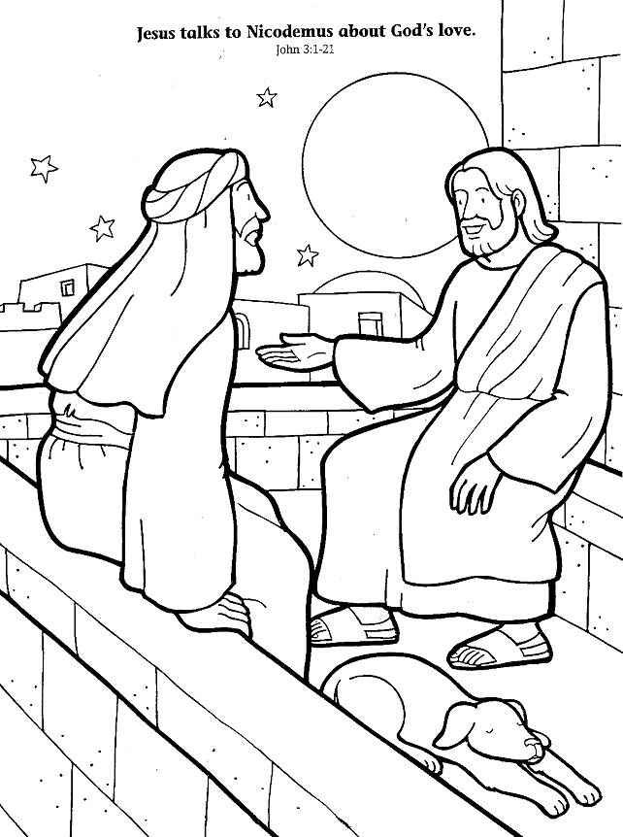
Please colour in – both kids and adults….colour together as a mindful activity.

