Family Prayer

Christmas

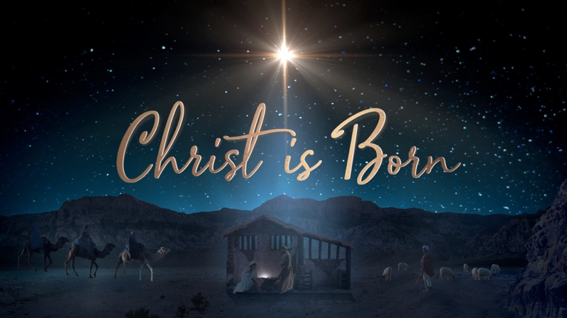

Setup - Before the prayer set up a sacred space. Clear your dinner table or other table. Include a candle, bell, symbols and coloured cloth. Invite others well ahead of time before you pray.

We put ourselves in the presence of our God by focusing on our breathing. Breath in and out. Breath in and out.

As we ring our bell and light our Candle
We invite God’s presence to be with Us.

Sign of the Cross.
In the name of the Father, and of the Son, and of the Holy Spirit.
Amen.

Song - O come, all ye faithful
https://www.youtube.com/watch?v=Y3egGjeiWEA

O come, all ye faithful, joyful and triumphant,
O come ye, O come ye to Bethlehem;
Come and behold him, born the King of angels;
O come, let us adore him, O come, let us adore him,
O come, let us adore him, Christ, the Lord!

God of God, Light of Light,
Lo! He comes forth from the Virgin's womb.
Son of the Father, begotten not created,
O come, let us adore him, O come, let us adore him,
O come, let us adore him, Christ, the Lord!

Sing, choirs of angels, sing in exultation,
Sing, all ye citizens of heav'n above!
Glory to God, all glory in the highest;
O come, let us adore him, O come, let us adore him,
O come, let us adore him, Christ, the Lord!

Yea, Lord, we greet thee, born this happy morning,
Jesus, to thee be all glory giv'n;
Word of the Father, now in flesh appearing;
O come, let us adore him, O come, let us adore him,
O come, let us adore him, Christ, the Lord!

Gospel – Luke 2:15-20
When the angels went away from them to heaven,
the shepherds said to one another,
“Let us go, then, to Bethlehem
to see this thing that has taken place,
which the Lord has made known to us.”
So they went in haste and found Mary and Joseph,
and the infant lying in the manger.
When they saw this,
they made known the message
that had been told them about this child.
All who heard it were amazed
by what had been told them by the shepherds.
And Mary kept all these things,
reflecting on them in her heart.
Then the shepherds returned,
glorifying and praising God
for all they had heard and seen,
just as it had been told to them.

The Gospel of the Lord.

All – Praise to you Lord Jesus Christ.

Song - Angels We Have Heard on High
https://www.youtube.com/watch?v=KGCxTOYBy50

Angels we have heard on high
Sweetly singing o'er the plains,
And the mountains in reply
Echoing their joyous strains.

Shepherds, why this jubilee?
Why your joyous strains prolong?
What the gladsome tidings be
Which inspire your heav'nly song?

Gloria, in excelsis Deo!
Gloria, in excelsis Deo!

Come to Bethlehem and see
Him Whose birth the angels sing;
Come, adore on bended knee,
Christ the Lord, the newborn King.

Gloria, in excelsis Deo!
Gloria, in excelsis Deo!

See Him in a manger laid,
Whom the choirs of angels praise;
Mary, Joseph, lend your aid,
While our hearts in love we raise.

Gloria, in excelsis Deo!
Gloria, in excelsis Deo!

Reflection Video
Father Jim McKeon
https://www.youtube.com/watch?v=ea2AfPDtAOk&t=318s

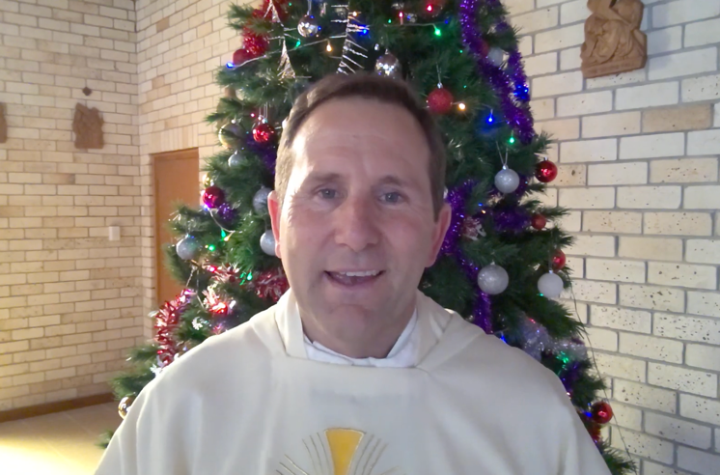

Silence
Take a minute in silence to reflect on today’s Gospel.

Discuss
- What happened in Father Jim’s story? How does it relate to Christmas?
- What does the story of Christmas mean?
- How can our communities bring about Christmas and Jesus in the world today?
- How can you bring Christmas and Jesus in your life today?

Prayers of the Faithful
We bring the following prayers to God.

1. May we be like the Shepherds. May we look for the signs of God in our times today. May we trust God and seek the Christ child in our lives. Lord hear us.

2. We thank for the birth of Christ this day. Encourage us to be more like Mary and Joseph. Despite the struggles we face, may we trust God more and more.
Lord hear us.

3. We pray for people who are lonely this Christmas. God please bring a ray of hope into their lives like the angels. May we strive to be the instruments of goodness in our lives. Lord hear us.

4. We pray for our world. Please bring peace to the hearts of men and women who create division and conflict. . Lord hear us.

Any other prayers?

Final Prayer
Come to us owe Holy Spirit.
May Christ be born in us today.
Bless us with gift of your Son.
God of yesterday, today and tomorrow
May your eternal Word
Transform our doubts and struggle
May the joy of your Son
Be with us this Christmas.
Amen

Hark! The herald angels sing
https://www.youtube.com/watch?v=djh02-DP9r8

Hark! the herald angels sing,
"Glory to the newborn King;
Peace on earth, and mercy mild
God and sinners reconciled!"
Joyful, all you nations, rise,
Join the triumph of the skies;
With the angelic host proclaim,
"Christ is born in Bethlehem!"
Hark! the herald angels sing,
"Glory to the newborn King!"

Christ, by highest heaven adored,
Christ the everlasting Lord:
Late in time behold him come,
Offspring of the Virgin's womb.
Veiled in flesh the Godhead see:
Hail the incarnate Deity,
Pleased as man with us to dwell,
Jesus, our Emmanuel.
Hark! the herald angels sing,
"Glory to the newborn King!"

Hail the heav'n born Prince of Peace!
Hail the Sun of Righteousness!
Light and life to all he brings,
Ris'n with healing in his wings.
Mild he lays his glory by,
Born that we no more may die,
Born to raise us from the earth,
Born to give us second birth.
Hark! the herald angels sing,
"Glory to the newborn King!"

Sign of the Cross.
In the name of the Father, and of the Son, and of the Holy Spirit.
Amen.

