Family Prayer

“The Wedding of Cana”

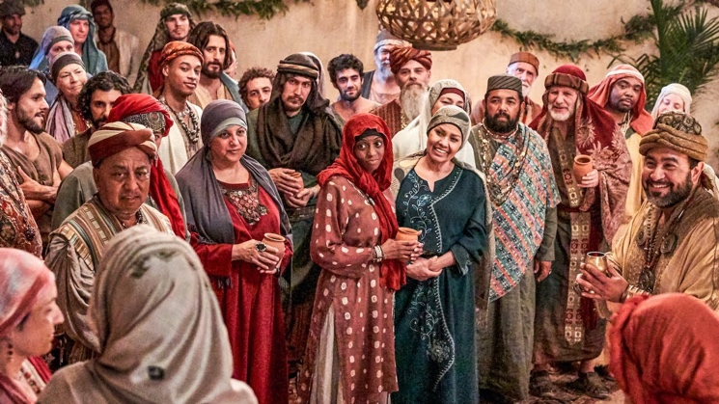

Setup - Before the prayer set up a sacred space. Clear your dinner table or other table. Include a candle, bell, symbols and coloured cloth. Invite others well ahead of time before you pray.

We put ourselves in the presence of our God by focusing on our breathing. Breath in and out. Breath in and out.

As we ring our bell and light our Candle
We invite God’s presence to be with Us.

Sign of the Cross.
In the name of the Father, and of the Son, and of the Holy Spirit.
Amen.

Song - All creatures of our God and King
https://www.youtube.com/watch?v=oIG1alC9m6w

All creatures of our God and king
Lift up your voices and with us sing
Alleluia, alleluia
Thou burning with golden beam
Thou silver moon with softer gleam
Alleluia, alleluia, alleluia, alleluia, alleluia,

Thou rushing wind that art so strong
Ye clouds that sail in heavâ??n a long
Alleluia, alleluia
Thou rising morn in praise rejoice
Ye light of evening find a voice
Alleluia, alleluia, alleluia, alleluia, alleluia,

Thou flowing water pure and clear
Make music for thy Lord to hear
Alleluia, alleluia
Thou fire so masterful and bright
That gives to man both warmth and light
Alleluia, alleluia, alleluia, alleluia, alleluia,
Wherever You would call me
Take me deeper than my feet could ever wander
And my faith will be made stronger
In the presence of my Savior

Gospel – John 2:1-11
There was a wedding at Cana in Galilee,
and the mother of Jesus was there.
Jesus and his disciples were also invited to the wedding.
When the wine ran short,
the mother of Jesus said to him,
“They have no wine.”
And Jesus said to her,
“Woman, how does your concern affect me?
My hour has not yet come.”
His mother said to the servers,
“Do whatever he tells you.”
Now there were six stone water jars there for Jewish ceremonial washings,
each holding twenty to thirty gallons.
Jesus told them,
“Fill the jars with water.”
So they filled them to the brim.
Then he told them,
“Draw some out now and take it to the headwaiter.”
So they took it.
And when the headwaiter tasted the water that had become wine,
without knowing where it came from
— although the servers who had drawn the water knew —,
the headwaiter called the bridegroom and said to him,
“Everyone serves good wine first,
and then when people have drunk freely, an inferior one;
but you have kept the good wine until now.”
Jesus did this as the beginning of his signs at Cana in Galilee
and so revealed his glory,
and his disciples began to believe in him.

The Gospel of the Lord.

All – Praise to you Lord Jesus Christ.

Song – Lord I need you
https://www.youtube.com/watch?v=_rR_Rdb1CTE

1. Lord I come, I confess
Bowing here, I find my rest
Without You, I fall apart
You're the one that guides my heart

Chorus :
Lord, I need You, oh, I need You
Every hour, I need You
My one defense, my righteousness
Oh God, how I need You

2. Where sin runs deep, Your grace is more
Where grace is found is where You are
And where You are, Lord, I am free
Holiness is Christ in me

Bridge:
So teach my song to rise to You
When temptation comes my way
And when I cannot stand, I'll fall on You
Jesus, You're my hope and stay
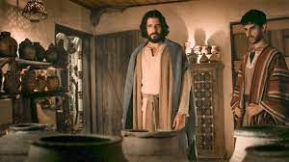

Reflection Video

“The Wedding at Cana”

https://www.youtube.com/watch?v=MhjvAAkXbj0

Silence
Take a minute in silence to reflect on today’s Gospel.

Discuss
- What does Mary do?
- The water used was used for hand washing. This is dirty water. What does Jesus do?
- What does the turning into wine represent?
- If Mary said to you “Do whatever he tells you”, what does it mean for us today?
- How can we follow Mary and Jesus?

Prayers of the Faithful
We bring the following prayers to God.

1. We pray for people effected by natural disasters. May we be a beacon of hope for the people effected. Lord hear us.

2. We pray that we too night trust more God. May we recognise God acting in our lives today. Lord hear us.

3. We thank God for the actions of Mary to prompt Jesus to act and for Jesus response in saying Yes. Lord hear us.

4. We pray that God will call each of us to work against injustice in the world. Lord hear us.

Do you have Any prayers to share today?

Final Prayer
Lord our baptism you washed us with water.
At the Wedding of Cana, you turned water into wine.
Change us Lord,
so that we might become beacons of hope
that make a difference against injustice
and places where God’s
loving embrace is deeply needed.
So like at the last supper,
Where the wine and bread become
Jesus’ own body and blood.
Transform us to be Christ hands, feet and heart
In the world today.

Amen

Song – A Rightful Place
https://www.youtube.com/watch?v=YBSIDHh0QBA

Chorus :
Let us live our lives so that all might see
That our hearts are restless till they rest in thee.
Let us build your kingdom in truth and grace
So that all might know they have a rightful place.

1. Beauty ever ancient and new,
Breaking through our deafness so we hear you.
Shattering the darkness of night,
A new dawn is rising to bring your light
To all the world.

2. To gather in your presence we came
To be one in spirit, in truth and name;
Strengthened by the body of Christ,
Taking up the call now to share your light
With all the world.

Sign of the Cross.
In the name of the Father, and of the Son, and of the Holy Spirit.
Amen.

