Family Prayer

“The Epiphany of the Lord”
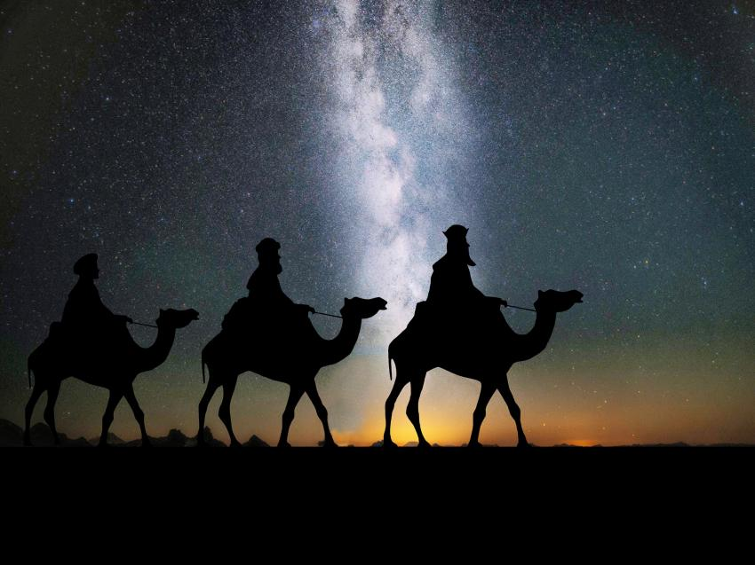
Setup - Before the prayer set up a sacred space. Clear your dinner table or other table. Include a candle, bell, symbols and coloured cloth. Invite others well ahead of time before you pray.

We put ourselves in the presence of our God by focusing on our breathing. Breath in and out. Breath in and out.

As we ring our bell and light our Candle
We invite God’s presence to be with Us.

Sign of the Cross.
In the name of the Father, and of the Son, and of the Holy Spirit.
Amen.

Song - We three kings
https://www.youtube.com/watch?v=k8mjRxkMBkE

1. We three kings of Orient are;
bearing gifts we traverse afar,
field and fountain, moor and mountain,
following yonder star.
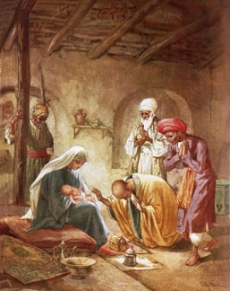
Refrain:
O star of wonder, star of light,
star with royal beauty bright,
westward leading, still proceeding,
guide us to thy perfect light.

2. Born a King on Bethlehem's plain,
gold I bring to crown him again,
King forever, ceasing never,
over us all to reign. [Refrain]

3. Frankincense to offer have I;
incense owns a Deity nigh;
prayer and praising, voices raising,
worshiping God on high. [Refrain]

4. Myrrh is mine; its bitter perfume
breathes a life of gathering gloom;
sorrowing, sighing, bleeding, dying,
sealed in the stone-cold tomb. [Refrain]

5. Glorious now behold him arise;
King and God and sacrifice:
Alleluia, Alleluia,
sounds through the earth and skies. [Refrain]

Gospel – Matthew 2:1-12
When Jesus was born in Bethlehem of Judea,
in the days of King Herod,
behold, magi from the east arrived in Jerusalem, saying,
“Where is the newborn king of the Jews?
We saw his star at its rising
and have come to do him homage.”
When King Herod heard this,
he was greatly troubled,
and all Jerusalem with him.
Assembling all the chief priests and the scribes of the people,
He inquired of them where the Christ was to be born.
They said to him, “In Bethlehem of Judea,
for thus it has been written through the prophet:
And you, Bethlehem, land of Judah,
are by no means least among the rulers of Judah;
since from you shall come a ruler,
who is to shepherd my people Israel.”
Then Herod called the magi secretly
and ascertained from them the time of the star’s appearance.
He sent them to Bethlehem and said,
“Go and search diligently for the child.
When you have found him, bring me word,
that I too may go and do him homage.”
After their audience with the king they set out.
And behold, the star that they had seen at its rising preceded them,
until it came and stopped over the place where the child was.
They were overjoyed at seeing the star,
and on entering the house
they saw the child with Mary his mother.
They prostrated themselves and did him homage.
Then they opened their treasures
and offered him gifts of gold, frankincense, and myrrh.
And having been warned in a dream not to return to Herod,
they departed for their country by another way.

The Gospel of the Lord.

All – Praise to you Lord Jesus Christ.

Song – What Child is This?
https://www.youtube.com/watch?v=5EKeNLPAjIQ

1 What Child is this, who, laid to rest,
On Mary's lap is sleeping?
Whom angels greet with anthems sweet,
While shepherds watch are keeping?

Chorus:
This, this is Christ, the King,
Whom shepherds guard and angels sing:
Haste, haste to bring Him laud,
The Babe, the Son of Mary!

2 Why lies He in such mean estate,
Where ox and ass are feeding?
Good Christian, fear: for sinners here
The silent Word is pleading.[Chorus]

3 So bring Him incense, gold, and myrrh,
Come, peasant, king to own Him.
The King of kings salvation brings;
Let loving hearts enthrone Him.[Chorus]

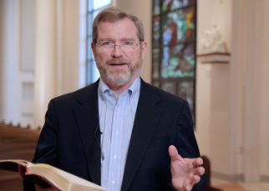
Reflection Video
Jeff Cavins https://www.youtube.com/ watch?v=yBP7tf6NiRo

Silence
Take a minute in silence to reflect on today’s Gospel.

Discuss
- What has happened in the story?
- The 3 kings prostrated or bowed down to Jesus? How can we do that today?
- What three gifts have you been given in your life?
- What is God trying to communicate to us?
- What happens when the light of the Lord shines?
- How does God reveal God self?
- How does Pope Francis reveal God?
- How can the light of Christ be revealed in your life?

Prayers of the Faithful
We bring the following prayers to God.

1. May we follow the stars and dreams that God gives to us. God give us courage to reveal the light of Christ in our lives. Lord hear us.

2. God, teach us to be generous with our gifts. May we give to others through generosity, compassion and forgiveness.Lord hear us.

3. We pray for places of conflict around the world. May we seek the peace. May we seek forgiveness. May we seek a change of heart. Lord hear us.

4. As we begin a new year, may we make new year resolutions which can make a difference. For our environment. For people suffering. For people suffering mental illness. For women and children facing domestic violence . Lord hear us.

Any other prayers?

Final Prayer
Come to us owe Holy Spirit.
May Christ be born in us today.
Bless us with gift of your Son.
God of yesterday, today and tomorrow
May your eternal Word
Transform our doubts and struggles
May the joy of your Son
Be with us this Christmas.
Amen

Song - Joy to the world
https://www.youtube.com/watch?v=TX6ThHbts5Y

Joy to the world! the Lord is come:
Let earth receive her King;
Let ev'ry heart prepare him room,
And heav'n and nature sing,
And heav'n and nature sing,
And heav'n, and heav'n and nature sing.

Joy to the world! the Saviour reigns:
Let us, our songs employ;
While fields and floods, rocks, hills and plains
Repeat the sounding joy,
Repeat the sounding joy,
Repeat, repeat the sounding joy.

He rules the world with truth and grace,
And makes the nations prove
The glories of his righteousness,
And wonders of his love,
And wonders of his love,
And wonders, wonders of his love.

Sign of the Cross.
In the name of the Father, and of the Son, and of the Holy Spirit.
Amen.

