Family Prayer

“The Spirit of the Lord is upon me to bring good news to the poor”

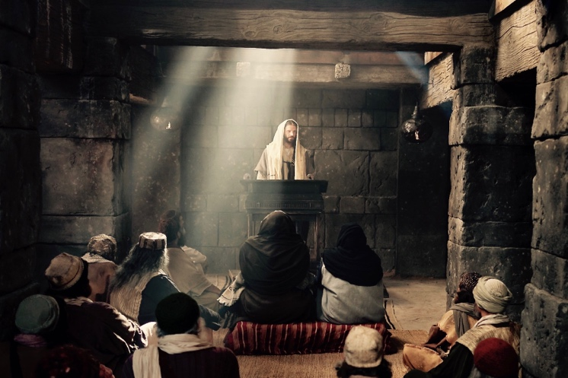

Setup - Before the prayer set up a sacred space. Clear your dinner table or other table. Include a candle, bell, symbols and coloured cloth. Invite others well ahead of time before you pray.

We put ourselves in the presence of our God by focusing on our breathing. Breath in and out. Breath in and out.

As we ring our bell and light our Candle
We invite God’s presence to be with Us.

Sign of the Cross.
In the name of the Father, and of the Son, and of the Holy Spirit.
Amen.

Song – God has chosen me
https://www.youtube.com/watch?v=0VWIpHq1Ctc

1. God has chosen me, God has chosen me
to bring good news to the poor.
God has chosen me, God has chosen me
to bring new sight to those searching for light:
God has chosen me, chosen me:

Refrain
And to tell the world that God’s kingdom is near,
to remove oppression and breakdown fear,
yes, God’s time is near, God’s time is near,
God’s time is near, God’s time is near.

2. God has chosen me, God has chosen me
to set alight a new fire.
God has chosen me, God has chosen me
to bring to birth a new kingdom on earth:
God has chosen me, chosen me:

3. God is calling me, God is calling me
in all whose cry is unheard.
God is calling me, God is calling me
to raise up the voice with no power or choice:
God is calling me, calling me:

Gospel – Luke 1:1-4; 4:14-21
Since many have undertaken to compile a narrative of the events
that have been fulfilled among us,
just as those who were eyewitnesses from the beginning
and ministers of the word have handed them down to us,
I too have decided,
after investigating everything accurately anew,
to write it down in an orderly sequence for you,
most excellent Theophilus,
so that you may realize the certainty of the teachings
you have received.

Jesus returned to Galilee in the power of the Spirit,
and news of him spread throughout the whole region.
He taught in their synagogues and was praised by all.

He came to Nazareth, where he had grown up,
and went according to his custom
into the synagogue on the sabbath day.
He stood up to read and was handed a scroll of the prophet Isaiah.
He unrolled the scroll and found the passage where it was written:
The Spirit of the Lord is upon me,
because he has anointed me
to bring glad tidings to the poor.
He has sent me to proclaim liberty to captives
and recovery of sight to the blind,
to let the oppressed go free,
and to proclaim a year acceptable to the Lord.
Rolling up the scroll, he handed it back to the attendant and sat down,
and the eyes of all in the synagogue looked intently at him.
He said to them,
“Today this Scripture passage is fulfilled in your hearing.”

The Gospel of the Lord.

All – Praise to you Lord Jesus Christ.

Video – Luke 4:14
https://www.youtube.com/watch?v=E2ojxNR8ECU

Song - Oceans
https://www.youtube.com/watch?v=8HgaCUbywxA&t=190s

1. You call me out upon the waters
The great unknown where feet may fail
And there I find You in the mystery
In oceans deep
My faith will stand

Refrain:
And I will call upon Your name
And keep my eyes above the waves
When oceans rise
My soul will rest in Your embrace
For I am Yours and You are mine

2. Your grace abounds in deepest waters
Your sovereign hand
Will be my guide
Where feet may fail and fear surrounds me
You've never failed and You won't start now

Bridge:
Spirit lead me where my trust is without borders
Let me walk upon the waters
Wherever You would call me
Take me deeper than my feet could ever wander
And my faith will be made stronger
In the presence of my Savior

Silence
Take a minute in silence to reflect on today’s Gospel.

Discuss
- Starting with S, what power did Jesus have? What is this?
- What was Jesus called to? What did the prophet of Isaiah say?
- Jesus fulfills the scriptures. What does that mean?
- How are we called to follow Jesus?

Prayers of the Faithful
We bring the following prayers to God.

1. We pray that we might be open to the call of Jesus in our lives. May we listen and flexible enough to respond to Jesus’ call. Lord hear us.

2. We pray that God will develop our faith and trust in God. May we more deeply enter the life of the Spirit. Lord hear us.

3. We pray for people facing oppression and persecution. Such as those falsely imprisoned and women facing domestic violence. Please help them Lord. Lord hear us.

3. We pray for the people of Tonga and other places facing disaster. May we respond and help them. Lord hear us.

Do you have Any prayers to share today?

Final Prayer
God you called your Son Jesus to fulfill the scriptures. May we too follow his examples and listen to your call.
May we go beyond our own comfort zones
And seek the poor, the needy and the forgotten.
Call us to bring good news to the poor.
Spirit bless us with your presence
And transform us
To be your instrument of peace.

Amen

Song – A Rightful Place
https://www.youtube.com/watch?v=YBSIDHh0QBA

Chorus :
Let us live our lives so that all might see
That our hearts are restless till they rest in thee.
Let us build your kingdom in truth and grace
So that all might know they have a rightful place.

1. Beauty ever ancient and new,
Breaking through our deafness so we hear you.
Shattering the darkness of night,
A new dawn is rising to bring your light
To all the world.

2. To gather in your presence we came
To be one in spirit, in truth and name;
Strengthened by the body of Christ,
Taking up the call now to share your light
With all the world.

Sign of the Cross.
In the name of the Father, and of the Son, and of the Holy Spirit.
Amen.

