Family Prayer

“The Baptism of our Lord”

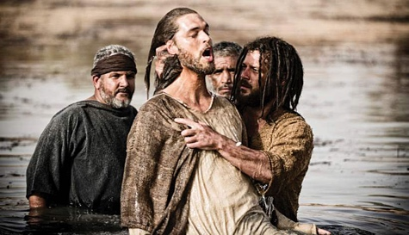
Setup - Before the prayer set up a sacred space. Clear your dinner table or other table. Include a candle, bell, symbols and coloured cloth. Invite others well ahead of time before you pray.

We put ourselves in the presence of our God by focusing on our breathing. Breath in and out. Breath in and out.

As we ring our bell and light our Candle
We invite God’s presence to be with Us.

Sign of the Cross.
In the name of the Father, and of the Son, and of the Holy Spirit.
Amen.

Song - Oceans
https://www.youtube.com/watch?v=6GGFb6LcX3U

1. You call me out upon the waters
The great unknown where feet may fail
And there I find You in the mystery
In oceans deep
My faith will stand

Refrain:
And I will call upon Your name
And keep my eyes above the waves
When oceans rise
My soul will rest in Your embrace
For I am Yours and You are mine

2. Your grace abounds in deepest waters
Your sovereign hand
Will be my guide
Where feet may fail and fear surrounds me
You've never failed and You won't start now

Bridge:
Spirit lead me where my trust is without borders
Let me walk upon the waters
Wherever You would call me
Take me deeper than my feet could ever wander
And my faith will be made stronger
In the presence of my Savior

Gospel – Matthew 2:1-12
The people were filled with expectation,
and all were asking in their hearts
whether John might be the Christ.
John answered them all, saying,
“I am baptizing you with water,
but one mightier than I is coming.
I am not worthy to loosen the thongs of his sandals.
He will baptize you with the Holy Spirit and fire.”

After all the people had been baptized
and Jesus also had been baptized and was praying,
heaven was opened and the Holy Spirit descended upon him
in bodily form like a dove.
And a voice came from heaven,
“You are my beloved Son;
with you I am well pleased.”

The Gospel of the Lord.

All – Praise to you Lord Jesus Christ.

Song – 10,000 Reasons
https://www.youtube.com/watch?v=DXDGE_lRI0E

Refrain:
Bless the Lord oh my soul
Oh my soul
Worship His Holy name
Sing like never before
Oh my soul
I'll worship Your Holy name

1. The sun comes up
It's a new day dawning
It's time to sing Your song again
Whatever may pass
And whatever lies before me
Let me be singing
When the evening comes

2. You're rich in love
And You're slow to anger
Your name is great
And Your heart is kind
For all Your goodness
I will keep on singing
Ten thousand reasons
For my heart to find

3. And on that day
When my strength is failing
The end draws near
And my time has come
Still my soul will
Sing Your praise unending
Ten thousand years
And then forevermore
Forevermore
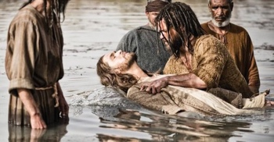
Reflection Video

The bible Documentary
“The Baptism of Jesus”

https://www.youtube.com/watch?v=CbwdLC_yAPs

Silence
Take a minute in silence to reflect on today’s Gospel.

Discuss
- Why does Pontus Pilot come to Israel from Rome?
- Why is John the Baptist baptising people?
- Who does King Herod think John the Baptist is?
- What question does John the Baptist ask? Why?
- Why does Jesus ask John to baptise him?
- What does baptism symbolise?
- What voice is spoken when Jesus is baptised? Are we too blessed?
- How do we live out our baptism each day?

Extension Questions

Baptismal Promises
The response to the following is “I Do”.

1.Do you reject Satan? Response.

2. And all his works? Response.

3. And all his empty promises? Response.

4. Do you believe in God, the Father Almighty, creator of heaven and earth? Response.

5. Do you believe in Jesus Christ, his only Son, our Lord, who was born of the Virgin Mary was crucified, died, and was buried, rose from the dead, and is now seated at the right hand of the Father? Response.

6. Do you believe in the Holy Spirit, the holy catholic church, the communion of saints, the forgiveness of sins, the resurrection of the body, and life everlasting? Response.

God, the all-powerful Father of our Lord Jesus Christ has given us a new birth by water and the Holy Spirit, and forgiven all our sins. May he also keep us faithful to our Lord Jesus Christ for ever and ever.
ALL - Amen.

Prayers of the Faithful
We bring the following prayers to God.

Do you have Any prayers to share today?

Final Prayer
Lord, we follow you in baptism
We go into the depths of water symbolising death
We rise out of the water symbolising new life
May we be resurrection people of baptism throughout our entire lives.
Restore us anew
Wash away our sin and shadow of darkness
Call us to be people of hope
To transform this world.
As a community of faith.
In the name of the Father, Son and Holy Spirit.
Amen

Song - Joy to the world
https://www.youtube.com/watch?v=TX6ThHbts5Y

Joy to the world! the Lord is come:
Let earth receive her King;
Let ev'ry heart prepare him room,
And heav'n and nature sing,
And heav'n and nature sing,
And heav'n, and heav'n and nature sing.

Joy to the world! the Saviour reigns:
Let us, our songs employ;
While fields and floods, rocks, hills and plains
Repeat the sounding joy,
Repeat the sounding joy,
Repeat, repeat the sounding joy.

He rules the world with truth and grace,
And makes the nations prove
The glories of his righteousness,
And wonders of his love,
And wonders of his love,
And wonders, wonders of his love.

Sign of the Cross.
In the name of the Father, and of the Son, and of the Holy Spirit.
Amen.

