Family Prayer
Mark 4:26-34 – Kingdom of God

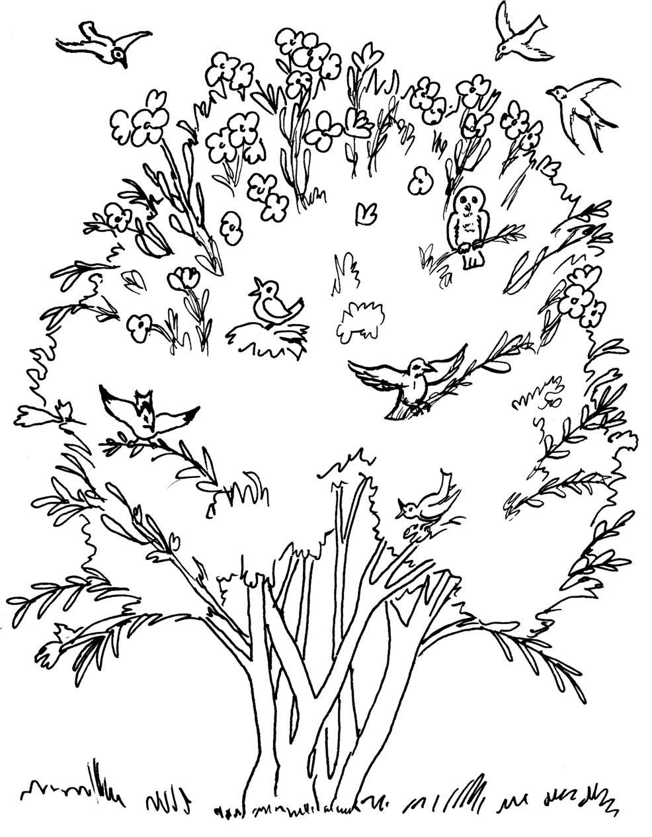

Opening Hymn
Lord I Need you - https://www.youtube.com/watch?v=_rR_Rdb1CTE
- Lord I come, I confess
Bowing here, I find my rest
Without You, I fall apart
You're the one that guides my heart

Chorus
Lord, I need You, oh I need You
Every hour, I need You
My one defense, my righteousness
Oh God, how I need You

- Where sin runs deep, Your grace is more
Where grace is found is where You are
And where You are, Lord I am free
Holiness is Christ in me

Bridge
So teach my song to rise to You
When temptation comes my way
And when I cannot stand, I'll fall on You
Jesus, You're my hope and stay

Gospel
Mark 4:26-34

Jesus said to the crowds:
“This is how it is with the kingdom of God;
it is as if a man were to scatter seed on the land
and would sleep and rise night and day
and through it all the seed would sprout and grow,
he knows not how.
Of its own accord the land yields fruit,
first the blade, then the ear, then the full grain in the ear.
And when the grain is ripe, he wields the sickle at once,
for the harvest has come.”

He said,
“To what shall we compare the kingdom of God,
or what parable can we use for it?
It is like a mustard seed that, when it is sown in the ground,
is the smallest of all the seeds on the earth.
But once it is sown, it springs up and becomes the largest of plants
and puts forth large branches,
so that the birds of the sky can dwell in its shade.”
With many such parables
he spoke the word to them as they were able to understand it.
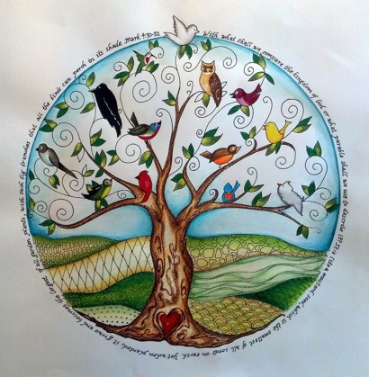
Without parables he did not speak to them,
but to his own disciples he explained everything in private.
The Gospel of the Lord.

ALL – Praise to you Lord Jesus Christ.

Gospel Reflection & Discussion
- What is the kingdom of God?
- How can we enter the kingdom of God?
- Why is the story of the sower and the mustard seed a good metaphor for the Kingdom of God?
- How can the Kingdom of God be good today?
- How can we nurture and help the Kingdom of God grow?

Common Prayer
1. We pray for people who have lost their faith. Especially our own family and friends. May they yearn for God and search God out. Lord hear us.

2. We pray for healing in the church. Especially those that have been hurt. May they find healing. Lord hear us.
3. We pray for areas in our world today where there is conflict and war. Especially Myanmar. Jesus pour out your peace Myanmar and other countries. Lord hear us.

4. Lord we pray for women and children suffering domestic violence. In our own country and communities. But also places like the Sanctuary in Baulkham Hills Sydney and Balay Banaang Davao. Help these places of refuge Lord. Lord hear us.

5. Any other prayers. Lord hear us.

Communion Prayer
Person 1 : May the Father in heaven make you good in your hearts.
All: May God make you good in your heart.

Person 2: Listen to the word of the Lord Jesus.
All: We will listen.

Leader Action – Hold the loaf bread in the air.

Person 1 : While they were eating, Jesus took a loaf of bread, and after blessing it he broke it, gave it to them, and said, ‘Take; this is my body.’ The bread has become the body of the Lord.

ALL: We cannot see this. But by the word of the Lord Jesus, we believe it.

Leader Action – Hold the cup in the air.

Person 2 : Then Jesus took a cup, and after giving thanks he gave it to them, and all of them drank from it. He said to them, ‘This is my blood of the covenant, which is poured out for many. The wine has become the blood of the Lord.

ALL: We cannot see this. But by the word of the Lord Jesus, we believe it.

Person 1 : Truly I tell you, I will never again drink of the fruit of the vine until that day when I drink it new in the kingdom of God.’

Person 2 : Through him, with him, and in Him. In the unity of the Holy Spirit. All glory and honour are yours forever and ever.

ALL - Amen

Aboriginal Our Father
Person 3 : You are our Father, you live in heaven,
We talk to you. Father you are good.
You are our Father, you live in heaven,
We talk to you. Father you are good.

Person 4 : We believe your word, Father,
We are your children, give us bread today.
We believe your word, Father,
We are your children, give us bread today.

Person 3 : We have done wrong, we are sorry,
Teach us, Father, all about your Word.
We have done wrong, we are sorry,
Teach us, Father, all about your Word.

Person 4 : Others have done wrong to us,
And we are sorry for them, Father, today.
Others have done wrong to us,
And we are sorry for them, Father, today.

Person 3 : Stop us from doing wrong, Father,
Save us all from the evil one.
Stop us from doing wrong, Father,
Save us all from the Evil One.

Person 4 : You are our Father, you live in heaven,
We talk to you, Father, you are good.
You are our Father, you live in heaven,
We talk to you, Father, you are good

ALL : Lamb of God who takes away the sins of the world, have mercy on us.
Lamb of God who takes away the sins of the world, have mercy on us.
Lamb of God who takes away the sins of the world, grant us peace.

Action – Break the loaf. Share and hold it before eating.

Leader – This is the lamb of God who takes away the sins of the World. Happy are those who are called to this supper.

ALL – Lord I am not worthy that you shall enter into my roof, but only say the word and my soul shall be healed.

Leader – The body of Christ.

ALL – Amen.

Action – Eat. Say private prayers in your heart for one minute.

Final Hymn - Good Good Father - https://www.youtube.com/watch?v=-ak0OoFBw3c

1. Oh, I've heard a thousand stories of what they think You're like
But I've heard the tender whisper of love in the dead of night
And You tell me that You're pleased and that I'm never alone

Chorus:
You're a good, good Father
It's who You are, it's who You are, it's who You are
And I'm loved by You
It's who I am, it's who I am, it's who I am

2.
Oh, and I've seen many searching for answers far and wide
But I know we're all searching for answers only You provide
'Cause You know just what we need before we say a word

