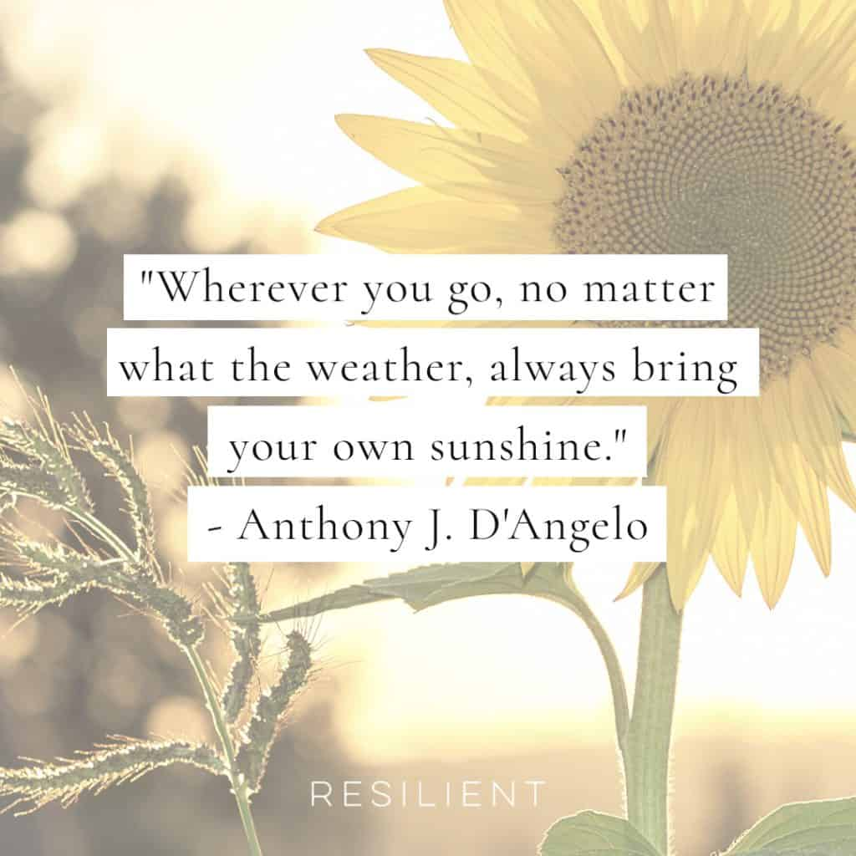

**Song – I am not alone – Kari Kobe**

<https://www.youtube.com/watch?v=Ow4OfW4DP9s>

**Common Prayer**

1. We pray for the times when we have not been resilient. We pray for the gift of courage. Inspire us not to run away from our fears but see them as opportunities of great growth. Lord hear us.

Response – “Lord hear our prayer”

1. We thank you Lord for when we have been resilient. We thank you Lord for strength to be a beacon of hope. Lord hear us

Response – “Lord hear our prayer”

1. We pray for our friends and family who lack resilience. Teach them to become more aware of you God as a source of hope, healing, courage and a willingness to bounce back. Lord hear us

Response – “Lord hear our prayer”

1. Any other Prayers.

**Final Prayer**

God be with us today. Teach us that courage is not the absence of fear, but, an opportunity of great growth. Teach us to enter into moments that most challenge us. When we fall down, encourage us to get up. Change the way we look at things. May we not see falling down as a threat, but as opportunity where your Spirit can dwell within us. Holy Spirit fill us with the fire of your love so that we renew this Earth. May the darkness become ablaze with your light God which shines through us.

In the name of the Father, and of The Son, and of the Holy Spirit. Amen.

**Discuss the quote -** “I'm living proof that even when something tragic happens, it's possible to achieve great things.” by Bethany Hamilton.

**Mindful Prayer**

**Session 2**

**“Resilience”**

YOUR NAME ____________________________________

Background music– “unbreakable “

<https://www.youtube.com/watch?v=WDxMas784iY>

As we light the candle

and ring the bell

we pray that God is with us this today.

Close your eyes.

Lay or sit with one hand on your belly and another on your chest.

*“Take a slow breath in from your belly, counting to 4.*

*Hold your breath in while counting to 7.*

*Release your breath completely and slowly, silently counting to 8.”*

Repeat 3 times.

In the name of the Father, and of The Son, and of the Holy Spirit. Amen.

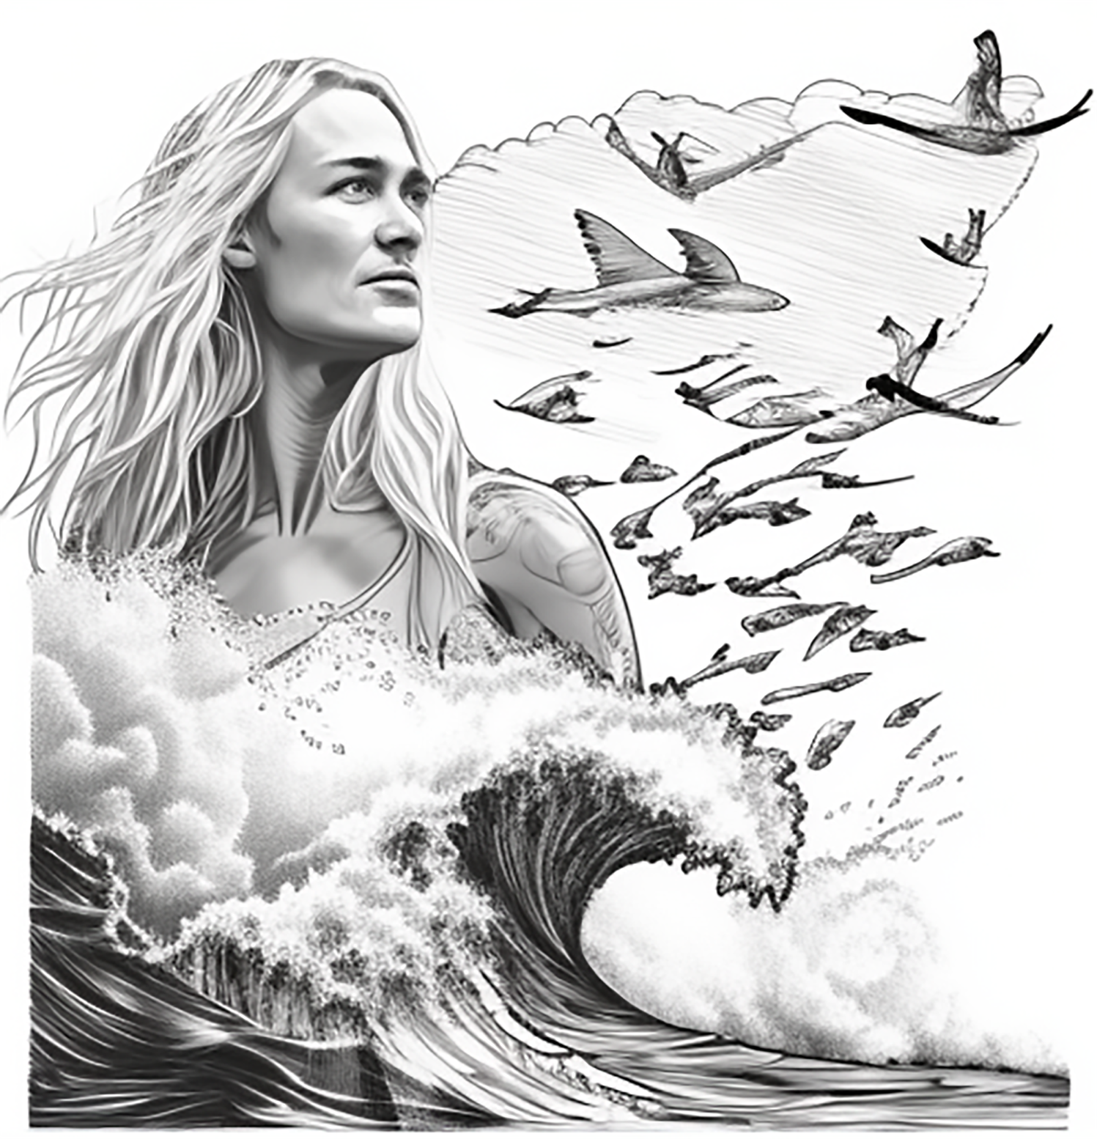

Draw or write about

“What are 2 examples when you have been resilient

but also 2 examples when you have not been resilient”?