Prayer for
Christmas

As we ring our bell, we invite God’s presence to be with us.

In the name of Father, and of the Son and of the Holy Spirit. Amen.

Opening Song - O Come O Come Emmanuel
O come, O come, Emmanuel,
And ransom captive Israel,
That mourns in lonely exile here,
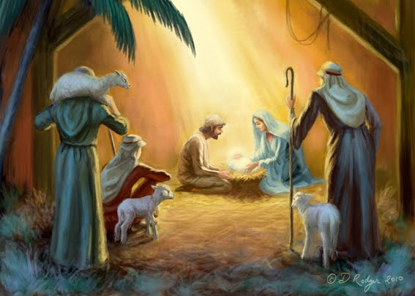
Until the Son of God appear.

Chorus:
Rejoice! Rejoice! Emmanuel
Shall come to thee, O Israel.

O come, O come, thou Lord of might,
Who to thy tribes, on Sinai's height,
In ancient times didst give the law
In cloud and majesty and awe.

O come, thou Rod of Jesse, free
Thine own from Satan's tyranny;
From depths of hell thy people save,
And give them victory o'er the grave.

O come, thou Dayspring from on high
And cheer us by thy drawing nigh;
Disperse the gloomy clouds of night,
And death's dark shadows put to flight.

O come, thou Key of David, come
And open wide our heav'nly home;
Make safe the way that leads on high,
And close the path to misery.

Opening Prayer
Lord, in this holy season of prayer and song and laughter, we praise you for the great wonders you have sent us: for shining star and angel's song, for infant's cry in lowly manger. We praise you for the Word made flesh in a little Child. We behold his glory, and are bathed in its radiance.

Gospel - Luke 2:15-20

When the angels went away from them to heaven,
the shepherds said to one another,
“Let us go, then, to Bethlehem
to see this thing that has taken place,
which the Lord has made known to us.”
So they went in haste and found Mary and Joseph,
and the infant lying in the manger.
When they saw this,
they made known the message
that had been told them about this child.
All who heard it were amazed
by what had been told them by the shepherds.
And Mary kept all these things,
treasured them in her heart.
Then the shepherds returned,
glorifying and praising God
for all they had heard and seen,
just as it had been told to them.

Gospel Reflection

The Angels were sign posts who gave directions for the Shepherds to find the baby God. God appeared as a fragile baby, not like the Greek or Roman God’s Thor or Odin who came with power and bolts of lightning. God appears in the unexpected simple child. For most people the child would have looked and acted like any other baby. Yet, the Angels were given a direction which revealed to them the deeper understanding of who the child was.

When have we had signposts in our lives which show us God unexpected nature? Can you think of anyone or any event which has awoken you to the deeper presence of God?

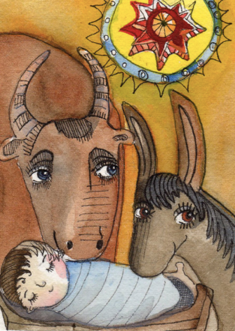
Why would God choose a manger to be born? Why an animal manager? This reminds us of the story of Noah. Noah build an ark to protect and symbolically house the animals. Animals are messy. Animals smelly. God steps down out of heaven and is born amongst the poorest. An outpost of the Roman empire inside a religion which was largely rejected by most Romans.

In our lives - how do we step out of our own riches and be present to the poorest parts of our world? Do we reflect God’s actions? To bring to life God’s Word. To invite God’s spirit to dwell in us and to be born in us.

Mary pondered and treasured these things. What things have you pondered and treasured in the last 12 months?

Questions

Discuss the following questions:

- What sign-posts such as people or events have revealed God in your life?
- How do we step out of our own riches and be present to the poorest parts of our world?
- When have we had signposts in our lives which show us God unexpected nature? Can you think of anyone or any event which has awoken you to the deeper presence of God?
- What things have you pondered and treasured in the last 12 months?

Song – Silent Night
1. Silent night, holy night
All is calm, all is bright
'Round yon virgin Mother and Child
Holy infant so tender and mild
Sleep in heavenly peace
Sleep in heavenly peace

2. Silent night, holy night!
Shepherds quake at the sight!
Glories stream from heaven afar;
Heavenly hosts sing Al-le-lu-ia!
Christ the Savior is born!
Christ the Savior is born!
Christ the Savior is born!

3. Silent night, holy night
Son of God, oh, love's pure light
Radiant beams from Thy holy face
With the dawn of redeeming grace
Jesus, Lord at Thy birth
Jesus, Lord at Thy birth
Jesus, Lord at Thy birth

Common Prayer
We bring the following prayers to God.

1. We thank you for year of 2020. The good and the bad. May you shower us Lord with your grace and gifts. Lord hear us.

ALL – Lord hear our prayer
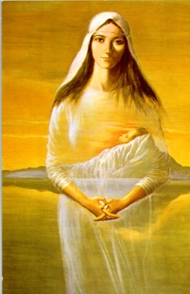
2. We pray for those that go without this Christmas. May their emptiness remind them of Christs own struggle. May Christs presence fill them with a sense of hope. Jesus be born in them today. Lord hear us.

ALL – Lord hear our prayer

3. We pray for our families. Christmas can be a stress filled time. Bring us peace to our families. Lord hear us.

ALL – Lord hear our prayer

4. We pray for our community and family. Break down the barriers of division and hatred. May we not judge each other. But as a community care for each other like Christ. Lord hear us.

ALL – Lord hear our prayer

5. We thank God for the goodness that you have given to us. For the wonder of creation. The earth, the stars and beauty of animals and all living things. Praise you God. Lord hear us.

ALL – Lord hear our prayer

5. Are their any other prayer?
………Lord hear us.

ALL – Lord hear our prayer

Final Song – Joy to the World

1. Joy to the world, the Lord is come!
Let earth receive its king;
let ev’ry heart prepare him room,
and heav’n and nature sing,
and heav’n and nature sing,
and heav’n, and heav’n and nature sing.

2. Joy to the earth, the Savior reigns!
Let all their songs employ
while fields and floods, rocks, hills, and plains,
repeat the sounding joy,
repeat the sounding joy,
repeat, repeat the sounding joy.

3. No more let sins and sorrows grow,
nor thorns infest the ground.
He comes to make his blessings flow
far as the curse is found,
far as the curse is found,
far as, far as the curse is found.

4. He rules the world with truth and grace,
and makes the nations prove
the glories of his righteousness,
and wonders of his love,
and wonders of his love,
and wonders, wonders of his love.

As we ring our bell, we invite God’s presence to be with us this Christmas.

In the name of Father, and of the Son and of the Holy Spirit. Amen.
