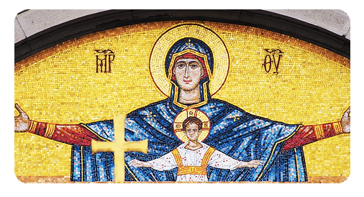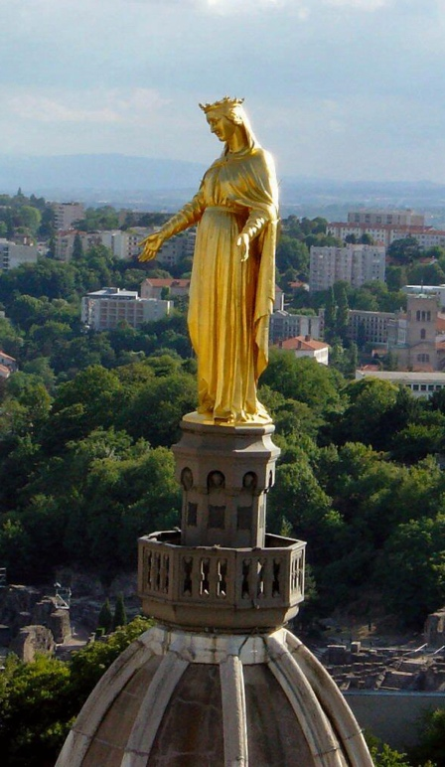

**Introduction**

Welcome to our celebration of Fourviere 2021. We gather today to remember, to be inspired and to reflect on the wonderful gift that the Marist Spirit has been to the world and continues to be through our presence in it.

As we gather let us still ourselves for a few minutes and allow our minds and souls to quieten so that calm and reflection may take its place.

Let us gather in thanks, that we live a spirit passed down for over 200 years and rejoice in the knowledge that the Lord of Life, works through us and in each of us, every day, as we endeavour to live Mary’s spirit that leads us to Christ and an everlasting love.

*Marist Laity Australia*

**Opening Song**

More than Memories –

Kevin Bates sm

*Thank you for joining today. Due to the current lockdown and the COVID restrictions we are unable to join together for a Eucharistic celebration and a meal. Following this prayer, we encourage you to celebrate Fourviere with your family and community members around a meal.*

*Marist Laity Australia*

*Please* ***subscribe*** *to our mailing list on web site*

[*www.maristlaityaustralia.com*](http://www.maristlaityaustralia.com/)

We pledge ourselves to accept all sufferings, trials, inconveniences and challenges, because we can do all things in Jesus Christ who strengthens us and to whom we hereby promise fidelity in the embrace of our Church.

Together we commit ourselves to the founding intuitions of the Fourvière inspiration that we may continue to be daring and responsive disciples of Jesus Christ, nourished with the words of faith and of the teaching which, by his grace, we have received.

**Save Regina**

Salve, Regina, Mater misericordiæ,

vita, dulcedo, et spes nostra, salve.

Ad te clamamus exsules filii Hevæ,

Ad te suspiramus, gementes et flentes

in hac lacrimarum valle.

Eia, ergo, advocata nostra, illos tuos

misericordes oculos ad nos converte;

Et Jesum, benedictum fructum ventris tui,

nobis post hoc exsilium ostende.

O clemens, O pia, O dulcis Virgo Maria.

**Closing Song**

Fourviere Pledge

**Litany**

Mary, Mother of the Church pray for us

St Joseph her husband pray for us

Our Marist founders pray for us

All our Marist saints pray for us

All Marist men and women pray for us

Fourviere

Prayer

**Discussion**

If these disciples of Jesus -men, women, children, priests, sisters,  
brothers, lay people- gathered together to rebuild the church,   
what would it look like?

*Pause in silence then discuss for 5 to 10 minutes*

***Prayers of the Faithful***

1.

We thank God for all Marists who have gone before us. The gracious choice of Mary and God’s calling of Marists to respond to Mary’s invitation. May we be filled with hope and commit to the challenge of the call.

Lord hear Us.

ALL - Lord hear our prayer.

2.

May our lives reflect Mary’s presence in the way we think, judge and act and like the early apostles at Pentecost, fill us Lord with the vitality of the Holy Spirit.

Lord hear Us.

ALL - Lord hear our prayer.

3.

We pray to that You nourish the Marist call in our lives. We pray to dream, to be creative and build fidelity through our commitment to Mary and God. May we dream big to meet the challenges of our times.

Lord hear Us.

ALL - Lord hear our prayer.

**Reflection**  
Michelangelo’s Unfinished statue

by Craig Larkin sm

In their haste to reach

Michelangelo’s statue of David,

tourists in Florence are often inclined to overlook

the unfinished sculptures in the hallways

leading to the room where “David” stands.

These pieces of sculpture

have been called ‘The Prisoners”

and they reveal what can happen

to an ordinary piece of stone

when the craftsmanship of a genius

draws from inside it

a perfection and form that others

would never have thought possible.

If a human genius can look at a piece of stone

and see possibilities that others cannot see,

what possibilities might God see

In human beings?

What “prisoner” inside each of us unlikely people is waiting to be released?

**Video**

A zoom conversation

about the meaning of

Fourviere.

4.

We pray that Marist across the world continue the mission of following Christ in the way of Mary. Call us to be Fourviere people with a youth filled energy, and challenge us to step out of our comfort zones. We pray that lay people will rise to the call of leading the Marist Charism within our local and international communities.

Lord hear Us.

ALL - Lord hear our prayer.

5.

Your own personal intentions and prayers.

ALL - Lord hear our prayer.

**Marist Commitment**

We, the Marists, striving to work together for the greater glory of God and the honour of Mary, Mother of Jesus, declare our sincere intention and firm desire of consecrating ourselves to building the Marian Church into the future.

That is why, by this declaration of solidarity as Marists, insofar as we can, we dedicate ourselves to the society of the Blessed Virgin.

We do not do this childishly or lightly or for some human motive in the hope of material benefit, but seriously, maturely, courageously, having taken advice, having weighed everything before God, solely for the greater glory of God, and the honour of Mary, Mother of Jesus.

